Supplier Training - Problem solving

Lately developed by Adient experts team, the Advanced 8D form is the enhanced format of the 8D form used in the past years. This is a comprehensive problem-solving document, used to
- guide the team through the 8D investigation steps
- track containment, permanent and preventive actions
- investigate the root cause (s) using standard tools - 5 Why, Ishikawa
- record various evidences, traceability of parts and actions, etc.

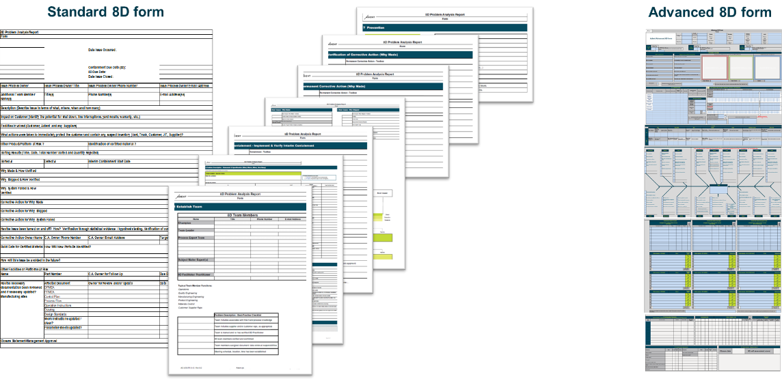

Using this new Advanced 8D form will generate valuable investigations and drive appropriate corrections and preventions for your specific quality issues.
As well, together with the 8D scoring form, meant to rate the accuracy of your problem-solving documents, we target the maximum efficiency of the process.

Adient is offering now 2 training classes, with external trainers, targeting to present Adient problem solving process and the specific forms in details:

1. Adient 8D process - overview

Location: Online
Duration: 2 hours Classroom (online) plus 2 hours Questions & Answers
Languages offered: English, German
What you will learn:
- What is the purpose of the 8D methodology?
- What are the contents, modules and requirements of the 8D methodology?
- How can I apply the 8D methodology for peak performance and top scorings?
- What does the Adient specific 8D form entail and how should it be used?
- What are the key differences between the Adient specific 8D Basic and Advanced forms and which ones are best for us?

2. Advanced Adient 8D training course
Location: Online
Duration: Total up to 8 hours; 2 hours Classroom (online); 2 hours Questions & Answers; up to 4 hours accompanying you with completing your individual form
Languages offered: English, German
What you will learn:
- Everything contained in the Adient 8D process - overview course
- We accompany you with completing your individual Adient specific Advanced 8D form
For any details related above courses, please contact the training provide directly: https://www.jmoellerconsulting.com/adient-trainings/

