Introduction

- This document contains tooling specific responsibilities. When conflicts arise between program specific statements of work (SOW) and these tooling responsibilities, this document will prevail.
- This document outlines the tooling expectations and definitions of responsibilities associated with the development of Stamping Dies for Adient, Inc. (Adient) through its part supplier (PS).
- All Tooling is subject to audit and approval by Adient.
- THIS DOCUMENT IS NEITHER A SUPPLY AGREEMENT NOR A PROMISE TO ENTER INTO A SUPPLY AGREEMENT. In the event Part Supplier enters into a contractual relationship with Adient (pursuant to a Purchase Order, Long-Term Agreement or some other written document executed by Adient designated as a form of supply agreement, hereafter called the “Contract”), the Contract shall govern the terms and conditions of the Part Supplier -Adient contractual relationship.
- In the event of any conflict between a term of the Contract and a provision of these Part Supplier Tooling responsibilities document, the Contract shall supersede and govern. In the event that a Contract has been or is entered into between Supplier and Adient, the procedures and obligations set forth herein shall be met by Suppliers and, if a Contract is consummated, shall become express warranties made by Supplier and Adient.
Part Supplier Tooling Responsibilities

- The PS is responsible for preparing and executing the tooling RFQ process, unless Adient has sourced the tooling prior to award. These responsibilities include, but are not limited to the following:
  - PS RFQ must clearly state that the tool must be designed and built, at minimum, to meet Adient Global Tooling and Gage Standards.
  - The RFQ must detail the process that will be utilized in production (type of tooling, number of stations, station description, etc.).
  - Tooling quotes must be received on the “Adient Die Cost Breakdown Worksheet”, and all appropriate fields must be completed in order to be valid. The number of stations and station description must be provided upon submitting quote.
  - The PS should schedule a joint meeting between the Operational Buyer, Tooling Buyer, the PS, and Adient Tool Engineer when all parties have received the quotes and are ready to discuss tooling cost, tool process, function, and timing.
  - All tooling quotes must reflect global market pricing.
- The PS is responsible for the successful launch of all tools. These responsibilities include, but are not limited to the following:
  - Review product designs and communicate and track change recommendations regarding simplifications of tool function, improvements, manufacturing feasibility, and cost reductions.
  - Build all tools to meet, at a minimum, Adient Global Tooling Standards & Adient Gage Standards.
            - Adient Global Stamping Die Tooling Standards
            - Adient Stamping Die Gage Standards
  - Obtain Released Data, CAD and drawing w/GD&T, prior to design and build of tool.
  - PS must obtain written sign-off by the Adient Advanced Tool Engineer (ATE) for the following phases of design; 0% - strip layout and 50% - tool design. Although Adient ATE’s approve the design, overall financial and functional responsibility of the tool resides with the PS.
  - Track and log all data levels, changes, agreements, and transmissions.
  - Obtain a Adient Purchase Order prior to kicking off tool design or build (includes engineering changes).
  - Provide tooling representation at Adient launch team meetings, design reviews, and customer tool shop visits as required.
  - Issue tool progress reports and tool-tracking spreadsheets to Adient throughout the build of the tools, which reflect the program deliverables and milestones.
  - Tryout material costs:
    - If Adient issues a PO directly to the Tool Shop, tryout material is included in initial tool PO. Material certification requirements are defined in the Adient Global Tool standard and must be adhered to by the tool shop.
    - If PS issues a PO for the tool, PS is responsible for all tryout material requirements throughout tool development. This material must be certified to meet material type defined on drawing.
  - Provide Adient with sample parts from the tool tryout runs upon request.
  - Shipping costs for tools:
    - If Adient issues PO directly to selected Tool Shop, PS must quote any cost delta for additional shipping costs beyond what was assumed in Adient quoted tool.
    - If PS issues PO for the tool, all shipping costs, duties, taxes, etc, must be included in quoted tool cost.
  - Perform all internal and external PPAP requirements for each tool to meet program timing and deliverables.
  - Manage and advise Adient on potential obsolescence during engineering changes, model year changes and production balance out.
  - When tooling is already started or completed prior to the PS being selected, the prospective PS is responsible to review, identify, and document any issues associated to the product design and/or tool design prior to signing the Award Letter.
- Unless tooling has been or will be sourced by Adient, the PS is responsible for sourcing the tooling at the agreed upon tool cost defined in the “Award Letter”. Tool source must be approved by Adient.
- For all tools with PO’s issued by the PS, the PS is responsible to support all Adient & Adient customer audits and provide documentation that reflects the cost of the Adient PO to the PS (supplier will provide tool shop invoices). The supplier will refund any Adient tooling payments that cannot be supported by appropriate documentation to Adient, in a timely manner. Upon Adient tooling PO, the part supplier must have completed the Adient Die Cost Breakdown Worksheet that supports the entire Adient PO amount. Payment will not be made to the PS until the Adient Die Cost Breakdown Worksheet documentation is received.
- All Adient / OEM CUSTOMER owned tools are to be identified per Adient and OEM CUSTOMER specifications.
  - The following items are considered tooling and therefore the property of Adient or the OEM:
    - Tools specifically made for the production of a part or parts unique to Adient or OEM CUSTOMER.
    - Unique computer software required directly for the production and or gaging of parts for Adient or OEM CUSTOMER.
  - The PS, for metal stamping, is responsible to affix a metal tag to the tool that contains at minimum: “Property of (insert OEM)”, OEM asset number, Adient Tool Number, Adient Part #(s), Part Name(s), Tool Suppliers Name, Address and Job #, Date of Manufacture, Material Thickness, Width, and Feed Pitch, Tool Dimensions (H x W x D), Total Tool Weight, Upper Die Weight and Outside Shut Height” This is in addition to any other tool markings specified in the Adient Global Tooling Standards and/or PS tooling standards.
  - The following items are not considered tooling and are not acceptable as part of a tooling bill, even if they are dedicated but not unique:
    - Generic tooling, general-purpose items, processing or capital equipment, quick change plates (common plates), and computer hardware. Lower common plates are allowed on transfer dies as defined in the Adient Global Tooling Standards.
    - The cost of or associated with automation, test equipment, process control equipment, manufacturing learning curve, launch costs, operator training, and vision cameras.
- Tool cost submitted to Adient is limited to the following: design of tools, tool build labor, tool build materials, one (1) tool sampling, tryout material, and initial tool shipment to the manufacturing facility. All gages must be quoted as a separate line item. Costs of capability studies are considered part of the supplier's overhead. A general percentage markup of tooling is not allowed. Adient must be notified of, and reserves the right to be present for any run-at-rates of new tooling. Costs associated with managing the tool build and launch are also considered part of the supplier’s overhead and will not be reimbursed under any circumstances.
- Adient reserves the right to decline payment of any tooling cost not supported by a Adient Tooling Purchase Order.
- A PS that designs, develops, or manufactures tooling in-house will provide all associated overhead costs in fully accounted tooling labor rates to Adient upon request. In addition, before placement of any tooling work with internal tool shops, the PS will provide evidence to Adient of competitive quoting with outside tool sources. PS records will be subject to audit.
- Engineering change costs must be validated individually by review of the tool cost breakdown sheet prior to issue of purchase orders. Changes that occur to tools after the tool build is complete are also required to have costs validated prior to issuance of purchase orders. Adient reserves the right to conduct run-at-rates after changes have been completed.
- Adient must be notified and agree to, in advance, the transferring of tools from one manufacturing site to another. The PS will cover all costs associated with the transfer of tools. Adient reserves the right to re-PSO (Part Sign Off) after tools have been transferred. The PS is responsible for design and build of all tooling used to manufacture parts awarded to the Supplier and shall meet all applicable Adient Global Tool Standards.
- The PS is responsible for the tooling for the entire life of the program, including the service period after production balance-out. Supplier will notify Adient in advance of implementing any engineering change if that change will impact the tool’s ability to provide service part requirements.
- The PS/Tool Shop building the tools should comply with QS 9000, TE Supplement.
- The PS is responsible for the tooling preventative maintenance and spare parts so as to meet all Adient manufacturing, delivery and quality requirements. Preventative maintenance plans must be documented and kept on file by the Supplier. Adient reserves the rights to review the Suppliers preventative maintenance and spare parts plans. If adequate record of a preventative maintenance cannot be documented, refurbishment costs to bring the function of the tool up to an acceptable level will be at the expense of the PS.
- The PS will insure and protect said property against loss or damage.
- In the event Adient in-sources or re-sources any tool from the PS, the tool must maintain all Adient Tooling Standards as defined in the approved tool design by the Adient ATE’s. As an example: If the tool was designed to Adient Tooling Standards with a shut height of 24”, the tool must exhibit a 24” shut height upon shipment of the tool to a Adient facility or new PS. If the tool is shipped not meeting the Adient Tooling Standard Adient will correct the tool to standard and debit the PS all costs associated.

*Include as “Attachment” in SSOW*

See Rasic chart below

Adient Sourced Tools

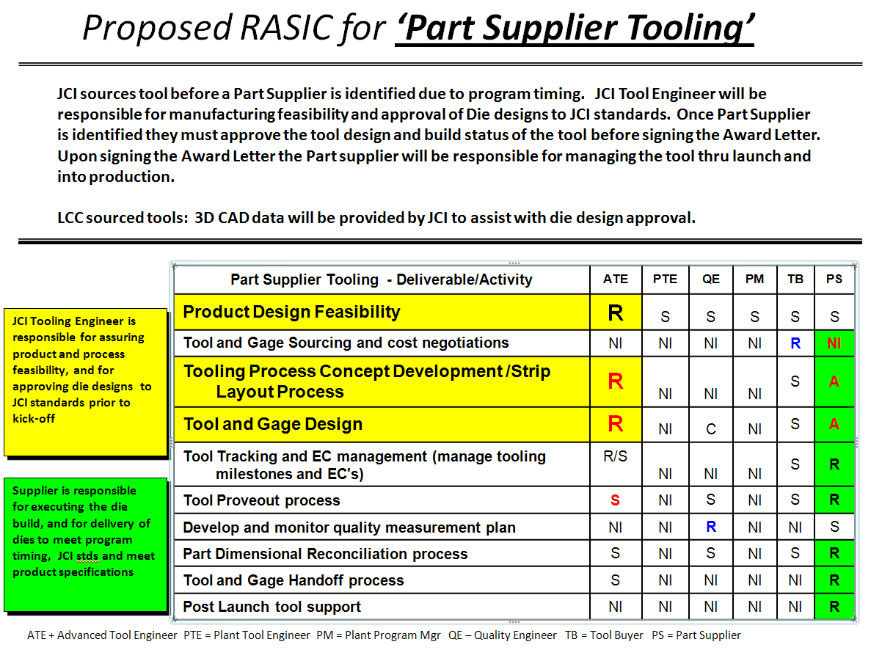

Part Supplier Sourced Tools

