1. **Purpose**
   1. The purpose of this procedure is to assure when a new die is being manufactured for Adient that the construction and performance is consistent with the guidelines set forth in the Tool specifications and expectations of the company.
   2. Tool Rating Measureables

* Tool to be delivered on time
* Tool to be 100% complete at delivery
* Minimal adjustments during run-off’s (4hrs allotted time)
* Part to Print
* Meet Adient PPM Goals
* Meet 77% Utilization Goals
* Minim Cost, Maximum Quality of Tools
* Build to Maximum Efficiency
* Meet set-up time
* Quality Parts at 1st off
* Tools must meet all Safety guidelines

1. **Scope**
   1. This Adient Die Specification applies to all worldwide locations of Adient for dies to be built to run at Adient stamping facilities as well as Adient stamping suppliers (i.e. Part Suppliers (PS)).
2. **Responsibility**
   1. The Global Tooling Integrator is responsible for ensuring Adient die specifications are met before, during, and after die construction.
   2. Any exceptions to Adient Global Stamping Die Standard must be submitted and approved in writing by Adient.
   3. This document will be used as a checklist during the tool buy-off procedure. Each item will be initialed if the standard is met in the tool. If the standard is not met in the tool, approval must be provided by the Adient ATE (Advanced Tooling Engineer). Otherwise the buy-off cannot be completed until the standards are fulfilled.
   4. All tools must be warranted for craftsmanship and production capability for a minimum of 50,000 strokes run in full auto. Tools will be tagged by vendor as warranted until the 50,000 strokes are complete. In the event of a die crash, Adient will leave the last strip in the tool and/or provide pictures of the damaged tool to the vendor upon a warranty claim. A report of how many strokes the tool has completed to date will also be provided.
   5. Adient will provide tryout material. Tool must be run-off with material supplied by Adient. Tool vendor is required to communicate the tryout material specifications, dimensions and timing requirements to the Adient Material Manager. Confirmation from the Adient Material Manager and ATE must be received and documented that all deliverables can be met. Any deviation from this requirement must be signed-off by the Adient ATE.
3. **Tool Build Process Requirements**
   1. **Design/Build/Buy-off**
      1. A part print and cad model will be supplied for the design. It is the responsibility of the tool designer to compare the part print and CAD model and report any discrepancies to the tooling engineer.
      2. At minimum, the GTS must perform a 1-Step forming simulation for any part that has potential of a stretch form. If the 1-Step simulation shows potential for failure, an incremental forming simulation must be completed. For any part that requires tension and or compression to form the part, an incremental forming simulation must be completed. If a potential failure exists as the result of the simulation, the GTS must work with Adient Engineering and ATE to resolve all potential forming issues before 100% design sign-off. All forming simulations must be performed using inputs that would establish worst case material properties for potential splitting based on the material specification on the drawing. This should also be performed at the low and high end of the material tolerance. It is the GTS’s responsibility to obtain all the appropriate specifications to perform the most accurate analysis possible.
      3. Written approval from Adient must be obtained by the GTS for any part the GTS pleads does not require a 1-Step or incremental forming simulation.
      4. Adient is to receive progress reports with a summary page (see Adient template) on the 10th and 25th of each month; Adient reserves the right to request a progress report between these times.
      5. Bidder must provide the following information with the initial quote: approximate die size (i.e. width, length, and shut height); estimated blank size (i.e. pitch, width), estimated tonnage, station/operation line-up including all active and inactive stations, and the press the die is quoted to run in during production.
      6. The Adient Tool Data Sheet must be provided upon 100% design review. Any changes in the tool design after the 100% design review must be resubmitted promptly. These data sheets need to be provided to the Plant Engineer Coordinator, ATE, and the Tooling Buyer.
      7. Prior to 50% design approval the GTS must provide the calculated tonnage required to make the intended product. The calculated tonnage must not exceed 80% of the press rated tonnage for the intended production press. It is the responsibility of the GTS to not exceed the press tonnage at Buy-off at the Adient/PS facility.
      8. If the calculated tonnage exceeds 80% of the press rated tonnage for the intended press, the GTS must obtain approval to proceed with design past 50% design approval. Upon approval, the GTS is responsible to not exceed the actual press tonnage agreed upon by Adient at Buy-off at the Adient/PS facility. The Adient presses monitor all (4) corners of the press for tonnage. Therefore the die must not overload any one corner of the press to successfully complete Buy-off.
      9. All designs are to be approved by Adient prior to die construction. The GTS must provide enough time to perform a proper design review and give one week notice before designs need to be approved. It is the responsibility of the GTS to manage the design reviews in order to maintain program timing.
      10. All die designs must be supplied in 3-D with 100% CAD models, surface data, bill of materials with perishable items identified and strip layout. The strip layout must have each station defined. Tools must be designed in 3D.
      11. Required data format for 2D design is “DWG” or “DXF”. Required data format for 3D design is “.stp”.
          1. Section views thru all working stations (i.e. non-idle stations). The section view must capture as many features as possible. This must be completed on the upper and lower die sections.
          2. Provide section views for both plan of die and plan of punch.
          3. 2D designs must have all details ballooned.
          4. Provide top view of the lower die. Provide a inverted top view of the upper die.
      12. Details must have a 2D design showing all holes and dowels.
      13. 2D drawings, CAD and BOM must be provided to the Adient stamping plant and Adient ATE after tool buy-off:
          1. Surface data used to create and cut any detail that is 3D. These details included, but are not limited to trim steels, form steels, pierce details: i.e. anything cut in 3D).
          2. Detail drawings for all cutting, piercing, form inserts and stripper window inserts. These drawings must be fully dimensioned.
      14. Detail drawings required for all cutting, form inserts and stripper window inserts. Drawings must be fully dimensioned
      15. All documents provided by the GTS to Adient/CM must be supplied in English.
      16. An itemized bill of materials (BOM) must be supplied for all perishable purchased items. This BOM must also include the supplier contact information and part number.
      17. All die details to be stamped with detail numbers and material specifications.
      18. All dies will be designed and built to metric standards. Identify that the tool was built to metric standards by stenciling “Metric” on both sides of the tool, top and bottom.
      19. Specify size of screws to be used for construction of the tool in the preliminary design review. Use only SAE 1960 Series socket head cap screws of equivalent.
      20. All fasteners must be HOLO-KROME.
      21. Minimum thread engagement must be 2 times the diameter of the bolt.
      22. Sharp edges should be broken on all blocks and plates to avoid injury to personnel (i.e. die blocks, removable holders, strippers, windows, die shoe, parallels, QDC plates, etc.)
      23. Working parts of the die may not extend beyond the peripheral limits of the die-set without written authorizations from Adient. This should be captured in the die design sign-off forms.
      24. All dies to run “Right” to “Left” unless specified otherwise. Exceptions will be documented and agreed to prior to 100% design approval.
      25. Two outboard hard stock guides are required on progressive and transfer dies. These guides must be at least 150mm long with the guide on the front of the die to adjustable to accept 6mm wider stock. Cylindrical slotted stock guides are not allowed in dies unless authorized in writing by Adient.
      26. All coil fed dies to have pitch notch trim on one side of strip capable of trimming 3mm, unless written exception is granted. Dies with stock below 1.5mm and/or wider than 400mm will have a pitch notch trim on both sides of the die. Dies are to be built so the steel is against pitch notches when in proper progression. Coil fed dies (including transfer dies) with a pitch greater than 200mm will require an alternative method of positive strip location other than what has been defined herein. This must be proposed, defined and approved by Adient at the tool design review.
          1. The pitch notch is to be used as the “first hit” indicator. If the “first hit” is other than the notches, a start line must be scribed in the die.
          2. If an incomplete part or a slug is generated when a new strip is started, a sample part or slug must be painted red and riveted to the die shoe at the position it has to be removed from the die.
          3. Pilot holes may not be pierced before the strip is against the pitch notches.
      27. Provisions in the tool (ex. Lifters in the lower die) must be accommodated to feed the initial strip for set-up through the tool unassisted. If it is identified during design that the product does not lend itself to incorporate this feature in the tool, this must be identified in the Adient Design Review Approval forms and signed off by a Adient representative.
      28. All designs must have scrap going through shoe and part off end of tool. A signed approval from Adient will be required for any deviation. A fixed “part out” chute must be supplied with the tool designed for the designated press intended to run the tool. Transfer tools to be supplied with scrap slides directing scrap to bolster openings or scrap conveyors. This must be defined by the 100% design review.
      29. All dies are required to have interchangeable stamp retainers for both part number, and manufacturing Julian date located in the coil fed section of the upper die set. If the stamps are required to be in lower die set a quick change type under coil must be used. Reference attachment for quick change design. Deviations require Adient sign off and approval.
          1. Adient Engineering must approve stamp location and type if not specified on part print
          2. Two out identical part dies must have cavity identifiers (i.e. F & B, L & R, X & Y)
          3. Use Argon brand stamps or equivalent taper lock type
          4. Use 9 position holders
          5. Date and part number stamps must be in place during any early part builds and tool buy-off runs.
      30. When product is designed with a hem, (3) operations will be required in the tool to make the hem. Any deviation from this standard will require sign-off from a Adient representative and identified on the Adient Design Approval forms.
      31. Die weight may not exceed a total weight over 30 tons. The upper die may not exceed 12 tons. The total weight of the tool must include parallels and change plates. Any die design that exceeds the weight requirement must be brought to Adient’s attention. Resolution to the weight issue must be defined on the tool design review sign-off forms. Preliminary weight calculations on all tools must be provided at the first design review.
      32. Dies will be supplied painted. Color to be defined by the stamping plant. All sections of the die that contact the product must be unpainted on the contact surfaces. Scrap chutes and guards will be painted safety yellow.
      33. Upper die shoe weight should be identified on the upper. Total die weight should be identified on the lower. Stencil on two sides with 50 mm high letters. Stencil part number on upper die shoe. Stencil “Front Side” and “flow direction” on the die. Removable chutes must have the die number on them for tracking purposes.
      34. Die storage blocks required on all tools for presses over 500T. “Flip-out” urethane blocks (i.e. Destaco Die Storage Bases/Blocks) should be used.
      35. Scrap shaker pans required for all tools that does not have scrap through bolster.
      36. Required Minimum Gross Tool Operating Speeds:
          1. Unless otherwise approved in writing, dies must be designed and built to run at the defined minimum strokes per minute (SPM) defined in 4.1.36.e. If required SPM stated in 4.1.36.e cannot be met, an explanation in writing detailing the restrictions must be included in the quote with the estimated achievable SPM.
          2. Die run-offs will require die to be run at the defined SPM for the 300 piece run in the GTS’s specified press and for 90 continuous minutes at the Adient/CM stamping facility.
          3. Mechanical movements or operations in the tool must not be limiting factor. If problems are anticipated, these must be notified to Adient in writing with explanations for the concerns.
          4. Tool Design must not to be limiting factor on achievable SPM on tool
          5. Targeted SPM per Adient Equivalent Press:

**Adient Equivalent Press** **Prog Die** **Transfer Die**

Kamotsu 400T 75 SPM N/A

Prog 600T and less 45 SPM N/A

Prog 600T to 1000T 40 SPM N/A

Transfer 400T to 880T 30 SPM 25 SPM

Transfer 1000T & over 30 SPM 20 SPM

* + - 1. Transfer dies must be run all under one ram and in auto with the production intended transfer bar/fingers at the GTS tool buy-off. They must run in automatic mode at the Adient/CM stamping facility at the rates identified above.
    1. Buy-off requirements at GTS:
       1. 300 strokes must be run in a continuous mode using coil fed system. Transfer dies must be run in full auto, under one ram, and use the production intended transfer bars/fingers.
       2. The intended stamping suppliers material lube must be used during tool run-off. Lube specification will be supplied by stamping source upon request from the GTS.
       3. Die is to be opened for inspection after 300 piece run-off at GTS location. This may require the tool to be disassembled.
       4. Parts must fit quality gage.
       5. Six (6) piece dimensional CMM layout to product print per quality measurement plan. This must be provided and approved by Adient/CM before buy-off visit is scheduled.
       6. A sample marked up with circle-grid lines must be provided for formed parts to confirm that thinning in the parts does not exceed the Adient thinning limits. See table of limits by steel grade and thickness and type of forming**.** GTS to provide analysis report with sample part.
       7. A TLD (thinning limit diagram) on ALL parts which has a stretch form must be supplied before buy-off visit is scheduled. No areas can exist in the marginal zone upon buy-off. (This process is preferred to be completed by the steel supplier).
       8. Max scrap length 305mm for transfer tools. When bypass cutters are used scrap must fall each stroke.
       9. Scrap must not accumulate more than 5 strokes on all other trimming or piercing operations, and fall away freely from the die once the wear land is passed.
       10. Screws must remain tight after the run, or corrective action must be taken.
       11. Complete bench review/tear-down of the tool at the GTS’s facility after tool run-off.

4.1.37l. All tools must run in continuous mode for the 300 piece run at the required SPM as defined in 4.1.36e. Any deviation from the required SPM must be signed off by the Adient ATE following the tool.

4.1.37m. The buy-off check (i.e. Adient Global Stamping Die Tooling Standards) sheet must be completed by the vendor and submitted to the Adient ATE before the tool is to be run-off.

* + 1. Buy-off requirements at Adient/CM facility:
       1. Tools must operate 90 mins. at rate in full auto. Stops allowed not attributable to die issues.
       2. The 90 mins. requirement may be reduced at the discretion of Adient.
       3. Parts must fit quality gage.
       4. (6) piece dimensional CMM layout to product print per quality measurement plan. This must be provided and approved by Adient/CM before buy-off visit is scheduled.
       5. A minimum Cpk of 1.67 must be achieved on a 30 piece sample on all SC’s and CC’s as identified on the drawing.
       6. Scrap must fall each stroke on any bypass cutter.
       7. Scrap must not accumulate more than 5 strokes on all other trimming or piercing operations, and fall away freely from the die once the wear land is passed.
       8. Screws must remain tight after the run, or corrective action must be taken.
       9. Final die buy-off requires receipt of 100% updated cad die design with BOM delivered at time of run-off.

4.1.39 At 100% design review, scrap removal system must be reviewed and approved by Adient. The complete die with QDC plates, “dog bones”, or any other peripheral items attached to the die must be considered with a scrap removal system in place to avoid all obstacles to allow unimpeded removal of scrap.

4.1.40 All documentation, design and tool must be 100% complete before scheduling a buy-off at the vendors facility. This includes and is not limited to pre run-off documents, 6 pc. layout (100% in tolerance), all check sheets complete, die tag information is complete and accurate, tool is painted, tryout material has been certified, etc.

4.1.41 If additional lube is required throughout the tool, oiler and oil lines must be permanently installed in the tool (nozzle type per plant requirement).

* 1. **Forms and Cutting Steels**
     1. Cast die steels are not permitted for forming or cutting steels.
     2. Cast FCS 50 or GM238 is permitted in forms as “horns”.
     3. All form or cutting steels welded during the die development must be replaced by the GTS in time for the Adient/CM plant buy-off.
     4. Cutting and Forming on the same section requires written approval by Adient. GTS must clearly identify during design review phase, and are responsible for obtaining written approval from Adient.
     5. All die sections are to be face mounted for removal in press. Sections to include jack screws.
     6. All one sided trims must be heeled, with the heel entering the die before the punch contacts the material. Heel blocks must not be steel on steel, Ampco type material must be used on one face. Heel blocks must be keyed to die shoe. Lower sections must be keyed or be pocketed on the opposite side of trim area. (Figure 3.). Deviations require Adient sign off and approval.
     7. Screw threads tapped into hardened steels must be 3mm counter-bored to prevent cracking out.
     8. All cutting and form sections are to be bolt & dowel replaceable with 100% cad data and dimensioned 2D drawings to be supplied by Global Tooling Integrator.
        1. All sections are to have the bolt & dowel patterns off-set to prevent the section being installed improperly.
        2. Dowels in an individual section must all be the same size.
        3. Dowels should be press fit into die shoe and slip fit into sections. Provide through hole to remove dowel pins. Absolutely no blind dowel holes.
        4. Bolted sections and punches should have threaded jackscrew holes between or adjacent to the dowels. Extractor threads should be the same size as the retaining bolts in that section.
        5. Larger sections must be keyed for greater support and ease of locating.
     9. All sections heavier than 100 pound to have handling hole to allow for removal of section by overhead hoist. Large sections must also have wedge slots to assist in loosening the section.
     10. Die sections must have a minimum wall thickness of 10mm. If part design does not permit, a product change request must be submitted in writing to Adient. If product change is not approved the area in the tool with this condition must use an insert that can be changed in the press. This condition must also be approved and signed off by Adient during the design review process.
     11. Provide clearance holes through the die shoe for all slugs and pilot holes.
     12. All sections are to be bolted such that when the section is sharpened and shimmed the die clearance and longevity of the trim steel is not affected.
         1. All cutting sections must have 10mm diameter minimum socket head cap screws and thread engagement must meet bolt specification.
         2. Top of socket head cap screw to be pocketed 10mm below the die life of die section to allow for sharpening.
     13. Blanking and trimming die sections to have 10mm die life. If not possible or feasible a written explanation must be identified on design review sign-off forms and approved by Adient.
         1. Die sections must be undercut below the “die-life” land. Wired burned sections may use tapered undercuts.
     14. All pierce buttons to be headless and key retained for easy removal. In a perforation pattern too small for inserts, use wire burned sections instead of buttons.
     15. All Buttons must incorporate tapered relief. Standard relief (step relief) buttons should not be used.
     16. No cutting steels to be larger than 250mm x 250mm without Adient Approval. Trim steel(s) must not exceed 30 lb. per section.
     17. Trim steel mismatch burrs on trim edges should be prevented with notches, but only by request to the Adient Engineering Manager or Tooling Engineer who must sign part prints to show and approve the locations (See Figure 2).
     18. If the product design requires a trim line or hole out of the die plane to maintain a profile/true position tolerance of 0.4mm, or less, cams will be required after the part has been fully formed. If cam trimming or piercing is not feasible or creates a weak die condition, alternate solutions must be approved by Adient in writing or product changes must be proposed and approved. This must be agreed upon and signed off during design reviews.
     19. 3-D cutting sections must be avoided. If approved by Adient in the design review, CAD surface models must be provided after buy-off at the GTS.
     20. All form steels are to be inserted allowing for easy adjustment. (See Figure 1 )
     21. Form sections must be direct mounted to the upper die shoe. Form steels may only be mounted on the strippers in special cases and must be approved by Adient at the 50% design review. This must be identified on the design review sign-off sheets with a Adient signature. In this case, the stripper must be made to bottom out onto blocks in the upper die. Form steels mounted on strippers require stripper to be guided by either pins & bushings or guide pads.
     22. Form steels working with offset loads must be heeled on the opposite side of the die shoe. Heel area must engage before forming starts. Heel blocks must not be steel on steel. Dis-similar material must be used on at least one face. Heel blocks must be keyed to the die shoe and/or pocketed.
     23. Crash forming is not allowed unless authorized in writing by Adient. This should be identified and signed off in the design review sign-off forms.
     24. Draw pads are required for areas where the part is likely to wrinkle or overlap when formed. Draw pads must have nitrogen springs (individual cylinders or manifold) plumbed to a common gauge with charge valve and min. 5mm hoses. Bolts and dowels must not extend into the working area of the draw pads. Adequate gauging must be provided to locate the part correctly into the draw station before it is gripped by the pads.
     25. Any draw beads and pad stand-offs must be shim adjustable in the press.
     26. Draw pads must be hand finished to compensate for material thickening.
     27. All large or closed draw forms to have breathers to prevent parts from sticking and to vent air.
     28. All trim steels must be removable inserts to allow for sharpening and replacing in the press. All sections must be mounted to CR or HR plate steel.
  2. **Steel Types and Coatings**
     1. All cutting steels must be A2 when the product design intent requires material 3.0mm and thinner, S7 cutting steel for any material thicker than 3.0mm.
     2. Commercial ball lock punches must be made of M2 steel. For tools that have a yearly planned volume that exceeds 1 million and/or have a material specification for the product with SAE J2340 420XF (JIS G3135 SPFC 540) or harder must come supplied with special wear resistant punches. Material type and/or coating must be approved by Adient in writing at design review.
     3. Absolutely no welds or fitted plugs on cutting steels.
     4. All forming & drawing steels are to be D2 tool steel or better.
     5. All drawing and forming operations that result in a “stretch bend” or “crush form” will require coating. Any coating used other than “TD Coating” must be approved by Adient ATE’s. Any forming or drawing operation that creates galling will be required to be coated.
     6. Coating for draw pads is only required in high wear areas. Where coating maybe required draw pads are to include hardened inserts mounted in 4140 pad retainer which will allow TD coating as needed.
     7. All extrusion sizing punches must be coated. All other extrusion punches will only need to be coated if galling is detected at run-off.
     8. Double draw heat treat process is required on all tool steels. Heat treat certification must be provided on all tool steel.
  3. **Punches/Pilots/Ball Locks**
     1. All trimming or piercing less then 25mm x 25mm sections or holes punches, stripper access window, etc. must be removable in the press.
     2. All punches and punch accesswindows will require a dimensioned 2D design.
     3. Punches that cut only on one side must be heeled, with the heel entering the die before the punch contacts the material. Heel blocks must not be steel on steel, Ampco type material must be used on one face. Heel blocks must be keyed to die shoe. (Figure 3.)
     4. Preferred mounting method for punches is bolting or heavy duty ball lock style holders. Punch ball seat location other than increments of 90 degree orientation is not allowed.
        1. Punches of similar size or shape must have different body diameters for error proofing
        2. Smaller shaped cutting punches may be mounted in several ways, as most appropriate for the punch shape and space available in the die. The method selected must be approved by Adient at design review.
           1. Mounted in a quick change holder
           2. Heeled into a special punch holder
           3. In-press accessible footed punches preferred. Alternative option with approval would be to held into wire burned punch holder with hardened washer (minimum 6 mm thick) and screw clip. Minimum 8mm screw.
           4. Direct retaining bolt.
           5. Taper locking punches in retainers are not allowed.
           6. Minimum of (2) bolts per section required.
     5. All punches require slug shedders unless punch size/shape will not permit.
     6. All hole diameters to be pierced between nominal and the high limit of the hole tolerance. If hole tolerance is as narrow as +/- 0.05mm, build to nominal.
     7. Pierce punches less than twice material thickness are not allowed. It is the GTS’s responsibility to review the Adient product design to insure this standard is not violated.
     8. Piercing is not allowed on an angle over 15 degrees normal to the part surface. For punches smaller than 15mm, the pierce angle may not exceed the punch diameter size in the amount of millimeters to degrees. Under 5mm 5deg, 6-10mm 6deg, 10-14mm 14deg, 15mm-above 15deg any deviations must be approved in writing. Inserts to be utilized in these areas.
     9. All pilots to be a minimum diameter of 10mm. Preferred diameter is 15mm.
        1. All pilot buttons to be keyed or headed and have 0.05mm. clearance per side maximum above pilot diameter. Buttons that are headed must be held by means of inserts avoiding removal of large sections to replace the buttons in the press.
        2. Pilots are to be “positive pick-up” style with a slug clearance hole drilled through the die shoe
        3. Pilot holders must be heavy duty ball-lock, mounted behind the stripper plates. The pilot must be removable through the stripper.
        4. Transfer tool pilots, or part locators, or lifters in lower die are to be easily removable in press. Pilots are to be held by keys or small inserts with jack screw provisions added.
        5. Different size pilots within the same tool must have different body diameters for error proofing.
        6. Pad mounted pilot pins are permitted only by signed approval from Adient. The pad must be fully guided and the pilots must have ejector pins beside them in the strippers/pressure pad.
        7. Pad mounted pilots that are held in by windows cannot share the window used for punches or trim steels.
        8. Threaded pilots are not allowed.
     10. Tube Dies containing pierce punches must be provided with lubrication through the stripper pads with plumbing for pressurized oiling of punches.
  4. **Strippers**
     1. All strippers are to be constructed of 4140-4150 steel non hardened plate or equivalent.
     2. Minimum stripper thickness for Dies over 1500mm in length is 35mm thick minimum.
     3. Detail drawings for each stripper plate and its inserts are required. These drawings must be fully dimensioned. Inserts must include jack screw holes.
     4. Strippers must be retained with keeper blocks and/or Standard size spools with 12mm bolts minimum.
        1. Spool must be accessible and removable without removing nitrogen units, parallels, etc., from the die.
        2. Shoulder bolts may not be used for retaining strippers.
        3. Keepers are to be fixed with min. (2) 12mm bolts. For dies over 600 ton use a min. of (4) 12mm bolts.
        4. Preferred square footprint on die shoe for keepers.
     5. Strippers should have window inserts allowing for removal of punches while the die remains in the press.
        1. Flat windows may be pocketed into the stripper for location. Bolt & dowel hole pattern must be designed to prevent incorrect installation.
        2. Contoured windows must be dowelled to the stripper for location.
        3. Windows must have threaded jackscrew holes for removal (same thread as retaining screws) and face mounted in die.
        4. Strippers should be cleared out so punches can be shimmed 10mm minimum. No Shoulder Screws.
        5. Clearance around punches through windows should be half product strip thickness
        6. Stripper windows should be made out of a 4140 steel or lesser grade steel. Do not make windows out of D2 or A2.
     6. Working strippers with hardened form inserts must be guided with guide posts and bushings sufficient to properly contain them.
     7. Cutting steels may not be mounted to strippers.
     8. Cams for piercing or trimming must have spring / nitrogen strippers at cutting interface. Fixed “bridge” or “finger” strippers are not permitted unless written approval at design review is signed by a Adient representative.
     9. Urethane strippers are not permitted. Exceptions only allowed with written approval from Adient during design review.
     10. Where areas of the part are likely to wrinkle or overlap material, a draw pad is required along with nitrogen springs. Bolt and dowel holes must not extend into working surfaces.
     11. Upper pad must have balancing blocks on lower tool to keep the pad level if the design concept of the die steels does not guarantee a balanced condition.
     12. In the case of tools with deep extrusions, each stage of the extrusion must have a separate stripper insert. These may be mounted on a common stripper plate. The extrusion punches should be headed (i.e. not ball lock) and the stripper window should be large enough to remove the punch holder in the press.
  5. **Die Shoe Specifications**
     1. Minimum thickness for all dies shoes shall be 75mm for lower die and 63mm for the upper die.
     2. Each die set (sub-die) must have 4 guide pins with ball bearing guides. One post must be offset to avoid miss-assembly of the die. For dies in presses less than 400 ton use 50mm guide pins. Tools for presses 400 ton and over use 75mm guide pins.
        1. Two post die sets will not be accepted, except in transfer conditions where bars need clearance, and only by specific Adient authorization at design review.
     3. All dies will be equipped with handling lugs in accordance with the weight of the dies.
     4. Cast die shoes are only allowed by special permission in writing from Adient. If approved, GM 238 is required for casting steel. Certification must be provided to Adient from the foundry. Special pattern review required on casting prior to foundry. No upper geometry may be cast into die shoe. Absolutely no cast cutting steels are allowed.
     5. All tools for presses 300 ton and over must have bi-directional thrust blocks installed on the die set to minimize potential damage if the die is miss-fed. Smaller tools with an off balanced forming load will have extra heel blocks welded on the die set to offset the load. This is to be determined at the design review.
        1. Thrust blocks must have Ampco 21or equivalent wear plates with graphite impregnated composition inserts.
  6. **Slug Clearance/Scrap Removal**
     1. Part and scrap cannot fall off the die at the same place, they must be separated.
     2. Maximum slug size is 150mm x 300 mm.
     3. Provide through holes in the die shoe to remove all scrap and slugs produced in the tool.
        1. Ample slug clearance must be provided. Scrap openings must be 25mm larger than the dimensions of the scrap, unless authorized in writing by Adient in the design review process.
        2. Scrap area between the bolster and die set must be a minimum of 100mm.
     4. Scrap guides or deflectors must be provided around all areas where slugs fall into the holes in the die shoe to avoid slugs collecting in the die.
     5. Scrap chutes that deflect the scrap through the bolster or off the side of the bed must be part of the tool, and must be supplied with the die. These scrap chutes must be bolted into the die and designed so the scrap does not pile up on any plates under or on the die. Requests for other types of scrap removal systems will be at the expense of the requestor.
  7. **Cams**
     1. All cams and cam sliders must work on commercially available wear plates with self-lubricating graphite plugs (Ampco 21 or similar), unless the cam design requires a dwell action. Steel on steel is unacceptable unless approved by Adient in writing at design review.
     2. All cams that form or require sensitive timing should dwell in the closed position to make the shut height of the press less critical.
     3. All cam drivers should be the width of the cam working area.
     4. All cam pads (bottom surface) must be a minimum of 1.5 x height of the cam (see Figure 7)
     5. All movable sections and cams must have grease fittings and grease grooves for proper lubrication.
     6. Gag cams must be approved by Adient ATE’s at design. Must be able to operate gag outside the die or be air operated. It must be clearly marked so the operator can identify the part number at the location of the gag. Instructions must be in place if multiple gags are used.
     7. Cams should be returned by nitrogen springs. A positive return should be added if possible, and if not a return sensor must be added. No finger type cam returns. Any cam systems without positive returns must be approved by Adient at design review.
     8. All trim lines with a 0.4mm profile tolerance on stretch bends, not in die plane, should be cam trimmed to achieve print tolerance. An adjustable coin block to increase capability of the trim edge without cams may be used on straight bends with no form.
     9. Use commercial cam guide units if possible. Confirm type with Adient/CM at design review.
     10. All cam trim and pierce units must be removable in the press.
     11. Aerial cams not allowed unless authorized in writing by Adient.
  8. **Springs and Nitrogen**
     1. Hyson or Dadco nitrogen cylinders must be used for all dies.
        1. Cylinders are to have self aligning rods and dynamic lubrication system.
        2. Manifold cylinder systems should utilize the non-breathing type of cylinder.
     2. Cylinder travel to be 75 – 90% of maximum cylinder travel.
     3. Die springs are not allowed.
     4. When the die is fully opened no preload must exist on the cylinders.
     5. All designs should be use standard catalog cylinder sizes. If longer rod extensions are necessary, transfer pins or kiss blocks should be used between the pad and the cylinder rod.
     6. All cylinders/springs must be fixed into the die shoe by individual screws or retainers.
     7. Nitrogen cylinders in the lower die are to have drain slots for drainage of liquids.
     8. All draw and forming stations must have nitrogen cylinders plumbed together as one unit or use a manifold. In other areas of the die where 3 or more cylinders are used together (i.e. lifter rails, pads) it must be discussed at the preliminary die design to determine if plumbing together is required. Dies with three or less cylinders must be easily accessible in press.
        1. Plumbed cylinders must use a minimum hose diameter of 10mm.
     9. All manifolds and plumbed cylinders must have a gauge, quick release fill valve and drain valve (control panel) on the front of the die.
     10. Operating pressure of each manifold to be stamped adjacent to gauge on the die shoe.
     11. Data sheets are required on all manifolds.
     12. Die springs may be used in commercial type stock lifters and push off pins, subject to approval at the die design review. If dies springs are approved by Adient to be used, the maximum die spring compression allowed is 25%.
  9. **Die Protection Sensors**
     1. All progressive dies must be designed and built with an end of die strip sensor (Misumi end of strip sensor), to verify that the strip has fed up completely without buckling in the die. The required sensor to be defined by the intended stamping facility before die buy-off.
     2. Coil fed transfer dies require this feed up sensor at the last station fed by the coil feeder.
     3. All coil fed dies must be designed and built with provisions for a fixed feed stop at the beginning of the die. French notch/pitch notch requires a mechanical plunger with a micro switch.
     4. All sensors must be proved out at the die buy-off at vendors facility.
     5. All sensors must be fully protected to prevent damage that may be experienced in a production environment.
  10. **Stamp Information**
      1. The following information will be stamped on the die shoe:
         1. Vendors company name including address and phone number.
         2. Vendors job number to aid in ordering replacement sections.
         3. Adient/PS Tool Number (must obtain from Adient or PS who will receive tool)
         4. Part Number
         5. Material thickness, width, and pitch
         6. Weight of upper die (identified on upper die)
         7. Total weight of die (identified on lower die)
         8. Outside shut height
         9. Adient Tool Identification number (TA)
         10. OEM Tool Asset/Tag Number (separate tag)

4.11.2 Before the tool is shipped to the Adient stamping facility or PS, identify the owner of the tool and provide the proper “Property of” plate on the tool.

* 1. **Stop Blocks**
     1. All dies to have a minimum of four stop blocks.
     2. Blocks must be a minimum of 50mm diameter.
     3. Stops to be manufactured to the exact inside shut height. Each stop block to be grooved at the center 10mm wide and 1.25mm deep.
     4. All stop blocks to be located between upper and lower parallels.
     5. One safety-block location to be provided on each side of the die.
  2. **Parallels**
     1. All parallels are to be ground top and bottom.
     2. Proper feed line and shut height to be maintained on all dies per Figure 4.
     3. Parallels used for clamping and locating must be dowelled to the die shoes and sub plates (if present).
        1. Parallels must have slotted feet for clamping. Slots will be 28.5mm wide and 65mm long. The position of the upper and lower clamping slots must match the Adient/CM press specified.
        2. Clamping flat area must be 100mm long and wide.
        3. Clamping height above press ram and bolster must be 50mm.
        4. If feet are not outside the die-set periphery, 127mm clearance is required above the clamping surface, for both upper and lower die-set.
        5. Lower parallels must have locating features to match the Adient/CM press specified. Tools must have die locators as shown in Figure 8.
     4. Parallels for dies 300 ton and over will be a minimum of 50mm thick.
     5. Parallels for dies 800 ton and over will be a minimum of 62mm thick.
     6. Bolts used for fastening parallels must be a minimum of 19mm diameter.
  3. **Transfer Tools** 
     1. All transfer tools require lower change master plate.
        1. Lower plate thickness to be 62 mm.
        2. Master plate clamping areas are to be 50mm thick over an area of 100mm x 100mm, with slots 28.5mm wide.
        3. Lower master plates must have locators to match the keys shown by the Adient/CM press specifications. Locators on master plate must be 4-way and 2-way (To be verified at design review.)
        4. All sub-plates must be 4 way located to the die shoes with either keys or removable headed line-up pins. This is up to GTS as to which type required.

* + - 1. 4 way locating features required for parallel alignment to master plate and die sets.
    1. Upper plates are not required. Upper die set is required to include die lifting mounting bars between parallels or ‘dog bone style’ mounted to each upper die shoe. Upper parallels must include sensor block mounted on both sides of parallel to detect hydraulic clamp position.

4.14.2.a. Upper parallels are to have clamping slots to match the Adient/CM press specifications.

4.14.2.b. Lower parallels and plates for transfer dies will have 1680mm minimum span.

* + 1. All transfer tools at that are coil fed will require a feed switch to insure stock has advanced to the required pitch. A “Banner QS18VN6LDQ8” sensor is required as part of the switch. Or equivalent to plant specification as defined at design review.
    2. If clearance issues associated to guide pins are identified during the design reviews, resolution must be identified and signed off by Adient on the design review sign-off forms.
    3. Preliminary die design must be shared and approved by the automation supplier (i.e. Transfer Finger supplier).
    4. Do not locate off of part form. Use only rough guides, and then locate off pilots in tooling holes or trimmed edges of the part. Rough locators must be adjustable with the ability to tune within the press. Clearance must be provided in the opposite die shoe for the full range of adjustability on the rough locators. Rough guide locators must have a minimum of 25 - 40 mm lead in.
    5. GTS should recommend pilot locations after award if not present in part design. The location(s) of the pilot holes must be submitted and approved by Adient Engineering.

4.14.8. Lifters need to be designed to allow the part transfer system to repeatedly pick up the part to achieve the required SPM. Upper die ejectors should be vertically above the lower lifters so that the part lifts squarely. Upper ejectors should be radiied so the part does not stick to them. Ejectors ((lower pin gas spring) must be able to be serviced in the press.

* 1. **Lifting & Handling**
     1. Die must have two places between parallels wide enough for lift fork to carry or make special carrying handles on each end of the die. Exact dimensions and positions to be confirmed at design review.
        1. Ex. For Adient Athens plant dies that weigh over 4 tons should have fork lift access places 215mm wide and 95mm min height, spaced 432mm min to 1400mm max between centers.
     2. Tooling components between lower parallels should be protected from damage with rigid blocks.
     3. Identification of fork access points to be painted on the die shoe.
     4. All dies to be equipped with eight (8) tapped holes for handling in accordance with the weight of the dies and positioned in order for the pick-up point on the crane to hold die at the center of gravity. Identify the hole size as metric or standard by either welding or machining an “M” or “S” next to each hole.
        1. 24-3.00mm mm tapped holes are required for dies under 4,536kg and 36-4.00mm tapped holes for dies 4,536kg and over.
        2. 80mm minimum hole depth.
        3. The eight (8) holes consist of four (4) on each side, two (2) on top and two (2) on bottom.
        4. Thread size must be stamped beside holes.
        5. Tie straps are required for locking the die for shipping.
        6. These lifting holes to be standard threads even on metric dies. Thread size to be stamped beside holes.
        7. All dies with change plates must include “dog bone” lifters balanced for the die center of gravity.
        8. Die handling devices must not impede the removal of scrap.
  2. . **Tonnage** 
     1. The Adient presses monitor all (4) corners of the press for tonnage. Therefore the die must not overload any one corner of the press to successfully complete Buy-off.

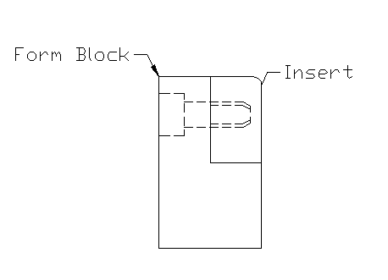

**Figure 1**

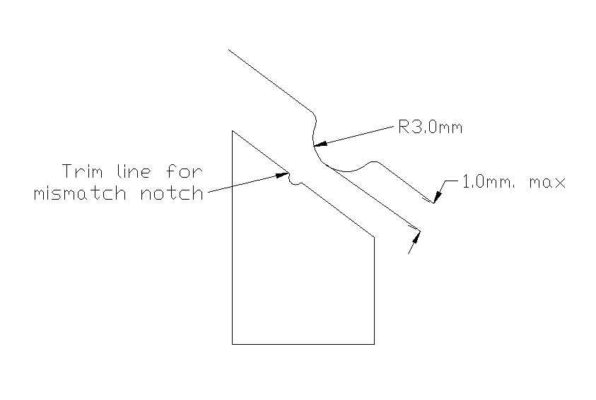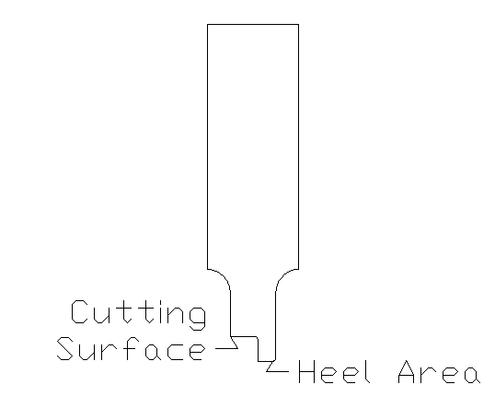

Figure 2 Figure 3

**Figure 4:** Standard for shut and feed-line heights (not including mounting plates)

All tools are to follow this standard for setting shut height and also feed height.

|  |  |  |  |
| --- | --- | --- | --- |
| Group | *Die Length* | *Shut Height* | Feed Height |
| 1 | *> 144"* | *40"* | 24" |
| 2 | *60" - 144"* | *24"* | 14" |

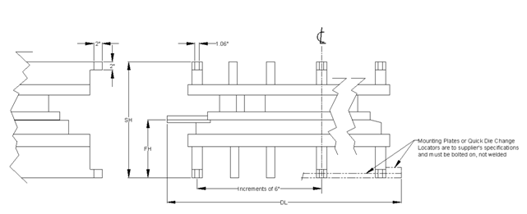

**Figure 5:** Material Thinning and Thickening Requirements





**Figure 6:** Stamp Retainer Quick Change Concept

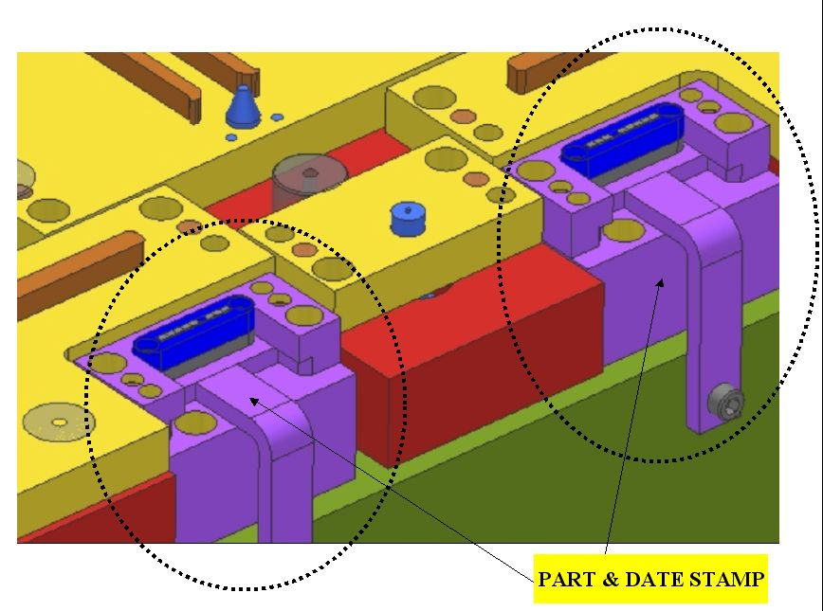

**Figure 7:** CAM Base-to-Height Ratio

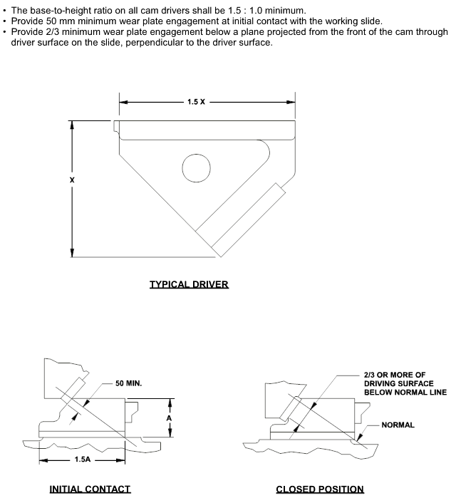

**Figure 8**: Kamotsu 400T Press Quick Locators

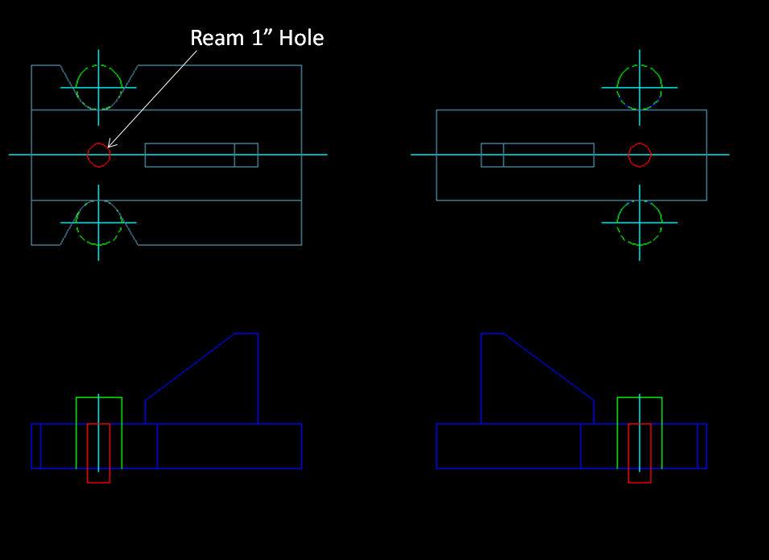

Europe Tooling Standards Addendum

1. OBJECT

* This document defines the specifications for new tooling for Adient.
* The goal is to establish a general specification to standardize every new tool.
* A finished tool includes the following activities:
* Design
* Manufacturing
* Trial runs and tooling adjustments including the trial and approval at the toolmakers and at the press shop/supplier in serial manufacturing conditions (stroke rate, coil or blank feed, transfer, etc.)
* Supplementary offers to any modifications must be presented in detail. Toolmaker’s hourly rates of pay must be presented to Adient for negotiation.

2.0 SCOPE

* All aspects in section 4.
* This General Tool Specification works in conjunction with the specific tool documentation and all other documentation which will be given to the toolmaker by Adient.
* If a conflict occurs between these documents, the Adient tooling engineer has to clarify the situation in writing.
* The toolmaker must make suggestions to improve the correct running of the tool.
* If the tool is to run at the supplier’s press shop facility, the design, manufacture and maintenance of the tool is the sole responsibility of the supplier.

1. RESPONSABILITIES
   1. Distribution of the Document

* The Adient tooling engineer is responsible for distributing the General Tooling Specification and all other related documents to the toolmaker.
  1. **Document Updating**
* This document will be reviewed regularly by the Manufacturing Engineering Department.

1. SPECIFICATIONS
   1. **Requirements**

4.2 Materials and Components

4.2.2 Materials and Surface Treatments

**4.3 Manufacturing Requirements**

**4.3.2 Tool Dimensions**

**4.3.4 Guides**

4.3.4.2 Location

4.3.4.3 Useful Guides

4.3.8 Scrap

4.3.10 Ribs in Cast Iron

4.3.11 **Security Elements**

4.3.11.4 Secure Elements for the Upper Tool

4.3.**14 Transfer Tool Specifications**

4.3.14.7 Transfer Bars

4.3.14.8 Passive and Active Fingers for Transfer

4.4 **Technical Documentation**

4.4.1 To be provided by Adient

4.4.2 To be provided by the Toolmaker

4.5 **Manufacturing and Acceptance of the Tool**

4.5.2 Trial Run and Approval at the Toolmakers

4.5.3 Trial Run and Approval at Adient or the Toolmakers

4.5.4 Guarantee

4.5.5 Safety

4.5.6 General

* + 1. **Materials and Surface Treatments**
* Materials require at minimum the listed characteristics.
* The materials include surface treatments which have to last the lifetime of the tool.

|  |  |  |
| --- | --- | --- |
| ELEMENTS | MATERIAL | Surface Treatment / HARDNESS |
| Cut and trim elements (punch, plate, bush) non-standardized | 1. 2379 | Hardened HRc 58-60 |
| Bending elements (males and females) | 1. 2379 | Hardened HRc 62-64 |
| Critical parts (with possible wearout problems) | 1. 2379 | PVD, TICTIN |
| Structure parts without main function | GC25 or ST37/52 | - |
| Structure parts with main function | GGG-70 | - |
| Stripper plates (draw tools) for large tools | GS-45 or GS-60 | - |
| Draw elements, stripper plates  (contact with sheet metal) | 1.2379 | Hardened |
| Draw elements, stripper plates  (contact with sheet metal )  for big volume or very thick | 1. 2379 | Hardened |
| Guides for console (centering press) | 1.2379 | Hardened |
| Guide ejectors, punch plates, bush plates | 1.2379 | Hardened |
| Stripper plate covers  (contact with sheet metal) | 1.2379 | Hardened |
| Chutes | Stainless steel channelled sheet | - |
| Flat guide bars | Bronze with non-liquid lubricant | One side bronze, the other side hardened |

**4.3.2 Tool Dimensions**

**4.3.2.1 Tool Height**

* The tools must be adapted to the assigned press chosen by Adient (or by the toolmaker for the UK).
* It is the responsibility of the toolmaker to ensure that the tool runs on the assigned press.
* The features of the press are contained in the Specific Tool Documentation (the following information is included):

**4.3.3.1 Use of Press**See The Adient Press Standards.

* + - 1. 

         Minimum length 40 mm

         **Location**
* The minimum distance between the end of the tool and the guide pillars should be 40 mm.
  + - 1. **Minimum Guide**
* The minimum length of the useful guide will be about 40 mm (see figure). A useful guide is defined as the contact length between guide bush-pillar when the tool starts to punch or trim. This applies to progressive and transfer tools.  
  + 1. **Scrap**
* Scrap has to be cut in a vertical direction and fall down by its own weight.
* Ensure that 100% scrap leaves the cutting bush by its own weight and, if necessary, a vibrating chute should be fitted.
* The scrap must leave at the side of the press and never by means of a central conveyor belt under the tool.
* If the angle of the scrap chute is less than 30º, vibrators have to be considered. The angle must be measured at the end of the press table (view drawing). The vibrators have to be pneumatic and standardized - see section
* The scrap chutes have to be made from stainless steel channelled sheet.
* Scrap bigger than 350 mm in diameter is not allowed.
  + 1. **Ribs in Cast Iron**
* The ribs are made from cast iron (upper and lower common plates, stripper plates):



* Sizes
* The minimum width of the inner ribs must be 40 mm in cast iron (GG25, 30, etc.). In the case of cast steel, the width can be smaller.
* The distance between two ribs in the general structure has to be 400 mm (maximum).
* Location
* The ribs must have an irregular position where possible. This results in greater strength.



Rib correct

Rib NOT correct

Rib correct

Rib NOT correct

* In the case of cutting tools, the ribs have to be located according to the cut profile (in the upper and lower structure) to absorb the efforts in this area.
* If these dimensions cannot be achieved, agreement must be reached with Adient in advance.
* If possible they should be made our of Aachener Profil
  + 1. **Security Elements**
       1. **Safety Systems in the fixed and adjustable elements of the upper tool**

1. **Ejector Plates, Stripper Plates**

* Ejector plates, stripper plates and other components (no normal replacement parts) have to be secured by a security distance screw. This will support the weight if breakage occurs.
* The distance screw is made from high strength steel, with a minimum strength of 120 kg/mm2.
* The distance will be 10 mm more than with the other distance screws (drawing).
* Safety + check screws must be accessible from the same side.

**4.3.13 Progressive Tool Specifications**

* + - 1. **Pitch Stops**
* Every progression tool has to stamp an initial punch in the sheet at the first pitch, which is used to insure that the stamping part runs correctly through the tool (if required).
  + - 1. **Sensors**

**The position and numbers of Sensors is definde from the production plant**

* + 1. **Transfer Tool Specifications**
       1. **Transfer Tracks**
* Transfer and adaptor (if required) tracks and fingers are part of the delivery and have to be designed by the toolmaker.
* More detailed information is available in the specific document.
* Electro- and pneumatic accessories belong to the scope of delivery.  
  + - 1. **Passive Fingers and Active Fingers for Transfer**
* The location of the passive fingers is defined in the design of the tool. There has to be enough space in the contact areas for the fingers.
* The fingers should be as passive as possible to simplify the transfer. The part sensors should be indirect.
* If it is not possible to use passive fingers, the Adient tooling engineer has to be contacted.
* ISI-NORGREN pneumatic fingers (latest model) are to be used
* If it is not possible to use the specified gripper model, different options have to be discussed with the Adient tooling engineer. Other fingers are allowed if agreed upon.
* Adient will provide the toolmaker with the electrical plans of the transfer.
* Fingers have to be designed to be strong enough.
  1. **Technical Documentation**

1. Lay out / Process study in CAD (“.dwg” and “.dxf “ format).  
   Component development documentation:  
   - Computer simulation must have « green » status

- Tool layout

- Part history

Manufacturing parameters (blank history, lubrication, press and gas spring pressure etc.)  
Tool maintenance plan

1. Conversion instructions
2. NC/CNC programs for all non-standard components in “.iges” or “.vda” format   
   (cutter path).
3. For further details, please see Tooling “Pflichtenheft”
4. All wearing parts must be accompanied by a drawing with exact measurements.
   1. **Manufacturing and Acceptance of the Tools**

**4.5.2 Trial Run and Approval at the Toolmakers**

* After finishing the trial run and when the tool is capable of making parts in line with all the specifications, the toolmaker will ship the following to Adient:

1) A minimum of six (6) parts with a dimensional report. This report will include all

measurements, specifications, tolerances, location points, etc. indicated in the drawing  
and / or numerical definition (CAD).

2) A minimum of sixty (60) parts with a dimensional report for significant characteristics (capability study).

3) A report showing the “nok dimensions”, explaining the reasons and corrective

action.

* Adient has to be kept informed about the manufacturing status of the tool and will attend the trial-run if required.
* Material for all trials will be supplied by Adient.
* After acceptance of the parts and the tool, the tool will be sent to Adient.
* The measurement report provided by the toolmaker can be a volumetric or dimensional measurement report. This will be indicated in the Specific Tool Document. If nothing is specified, the toolmaker will decide which type it should be after consultation with Adient.
* If the report dimensional, it should include (at least) the following information:
* Nominal dimension
* Upper and lower tolerances in accordance with VDA etc.
* Value of the measurement
* Deviation report
* If the report is volumetric, it should include (at least) the following data:
* Type of measurement (trim, form, holes, etc.)
* Tolerance
* Deviation report between measured value and CAD data (x,y,z values)

The reference points for the measurements have to be specified in the drawing. If they are not specified, Adient should be consulted.

**4.5.3 Trial Run and Approval at Adient or Toolmakers**Two conditions must be met for the definitive approval of the tool:

1. Acceptance of the part by Adient’ Q-Department

2. Manufacture on the home press in serial manufacturing conditions

(minimum stroke rate as per “Pflichtenheft”, coil or blank feed, transfer, etc.)

* The volume of parts the tool has to produce is defined in the specific tool documentation.
* The final adjustments to the tool will be made during the trial at Adient (home press).
* The final adjustments to the tool should be finished before delivery and included in the total tooling costs.
* Adient will provide all the machines and human resources needed to manage the trial run.
* Tooling adjustments on the production presses must be carried out mainly at the weekend.
* The press will be made available for 3 shifts. If more capacity is required, the toolmaker will be charged accordingly.

**4.5.4 Guarantee**

* The toolmaker has to guarantee that the tool is running correctly and that the manufactured parts meet all the specifications.
* The tool has to make ok parts during the lifetime of the project (the volume will be estimated) in normal running conditions and with adequate maintenance.
* For hidden defects not identified during the trial run, the guarantee will start from the time the defect appears.
* Repair work caused by hidden defects are the responsibility of the toolmaker.
* Repair costs due to defects during the guarantee period are to be carried by the toolmaker.

**4.5.5 Safety**

* The toolmaker has to ensure that the tool is built in line with all directives relating to accident prevention at the workplace.
* The design will be reviewed and approved by Adient from the technical aspect of accident prevention.
* Complaints arising from safety defects will be corrected by + charged to the toolmaker.

**4.5.6 General**

* The toolmaker has to manufacture the tool in line with current European specifications:   
  UVV, DIN, TÜV, VDE, VDS, EU, etc.