Adient – MX Business Rule VIRTUAL OPERATIONS

According to Mexican Customs Law 185-B, Temporary Import as well as Virtual entry, both imply a legal and fiscal obligation facing to the Mexican Government for all IMMEX Company in Mexico
The key idea is that the original importer must prove at any time, the origin, destiny and customs legal status of the goods located at their facilities.
The purpose of this business rules regarding Virtual Operations is to establish the steps to get an appropriate management and control of this special operations.

Virtual Operations applies when goods are transferred or sold in Mexico Geography.

1.- Supplier must identify business relationship according to scenarios applications described below.

2.- Adient have the option to make virtual operations in cases of favorable Adient business reasons related to savings and simplify procedures.

3.- Supplier must notify to purchasing area the intention of making virtual operations, until business relationship had been identified.

4.- Once Adient Purchasing had evaluated the possibility to make virtual operations, must communicate to Customs Analyst and Supervisor in Adient, to define appropriated date to start virtual operations, as well as define Tax code modified to show correctly in PO.

5.- Supplier must provide his customs contact and ensure customs compliance regarding:
- Number of IMMEX, ECEX, Fiscal Warehouse Program.
- Provide Certificate of Origin.
- Part number data.
- Mexico Broker information.

6.- Customs Supplier and Customs Adient must review both virtual pedimentos (import/export) to accurate information integrity, and work together about any failure or inconsistency on the process, and both decide suspension or total deferment of virtual operations.

Information to review in Virtual Pedimentos (Entries)
- Date
- Certificate or Origin (if is applicable )
- Program Prosec
- Importer/Exporter Name
- Applicable Period
- Quantities
- Invoices declared

Application Scenarios:

Business Relationship |  | Customs Operations |  | Transfer of Goods
Seller (Supplier) | Buyer(Customer) | Importer | Importation Regimen of Transferred Goods | Virtual Exporter | Virtual Importer
A | B | A’ |  |  | B’
Foreign Resident | Foreign Resident | IMMEX  Company | Temporary | Same A | 1.- IMMEX Company  2.- OEM or Fiscal Warehouse Program (Fiscal Deposit)

Rule (5.2.5.(1))

  - Foreign Resident sells to another Foreign Resident
A’ IMMEX Maquila which Imports and ship to another IMMEX in Mexico
  - Foreign Resident which buys items
B’ IMMEX which receives Transferred good but no buy them

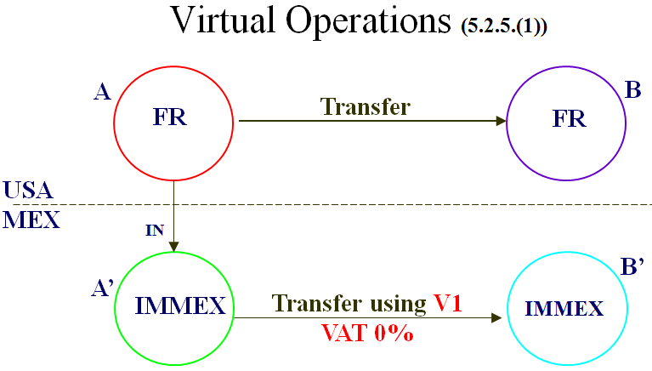

Business Relationship |  | Customs Operations |  | Transfer of Goods
Seller (Supplier) | Buyer(Customer) | Importer | Importation Regimen of Transferred Goods | Virtual Exporter | Virtual Importer
“A” | “B” | “C”
Foreign Resident | 1.- IMMEX Company  2.- OEM or Fiscal Warehouse Program (Deposito Fiscal) | IMMEX  Company | Temporary | Same “C” | Same “B”

Rule (5.2.5.(2))

"A" Foreign Resident which transfer goods to an IMMEX in México.
"B" IMMEX Maquila which import and ship to in México to another IMMEX
"C" IMMEX which receives foreign bought goods

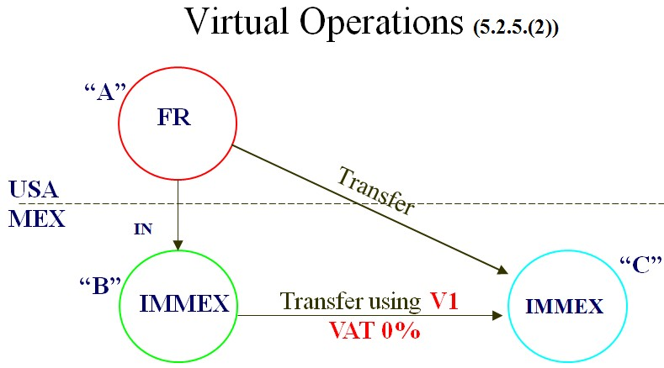

Business Relationship |  | Customs Operations |  | Transfer of Goods
Seller (Supplier) | Buyer(Customer) | Importer | Importation Regimen of Transferred Goods | Virtual Exporter | Virtual Importer
“A” | “B” | “C”
IMMEX  Company | Foreign Resident | Same “A” | Temporary | Same “A” | 1.- IMMEX Company  2.- OEM or Fiscal Warehouse Manufacturer (Fiscal Deposit)

Rule (5.2.5.(3))

"A" Foreign Resident which buys goods.
"B" IMMEX Maquila which sells in the foreign and ship to in México to another IMMEX.
"C" IMMEX which receives but no buys

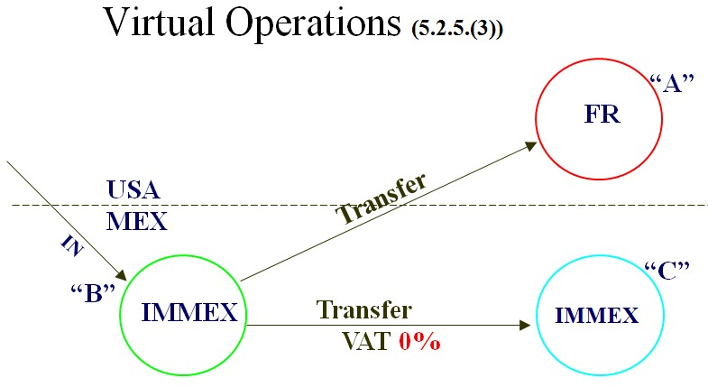

Business Relationship |  | Customs Operations |  | Transfer of Goods
Seller (Supplier) | Buyer(Customer) | Importer | Importation Regimen of Transferred Goods | Virtual Exporter | Virtual Importer
“A” | “B” | “C”
IMMEX  Company | 1.- IMMEX Company  2.- ECEX Company  3.- Strategic Fiscal Warehouse | Same “A” | Temporary | Same“C” | Same “B”

Rule (5.2.6.(A))

“A" – IMMEX which sells or transfer goods in México to another IMMEX
“B" – IMMEX which buys or receives transferred goods

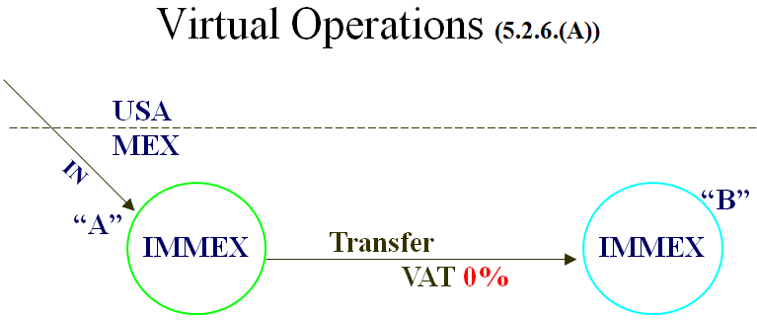

Business Relationship |  | Customs Operations |  | Transfer of Goods
Seller (Supplier) | Buyer(Customer) | Importer | Importation Regimen of Transferred Goods | Virtual Exporter | Virtual Importer
“A” | “B” | “C”
National Supplier | Foreign Resident | Same “A” | Definitive, Permanet or National | Same© | 1.- IMMEX Company  2.- OEM or Fiscal Warehouse Manufacturer (Fiscal Deposit) 3.- Strategic Fiscal Warehouse

Rule (5.2.6.(B))

"A" – National Supplier which sells in the foreign and ship to in Mexico to an IMMEX
"B" – Foreign resident which buys goods
"C" - IMMEX which receives but no buys

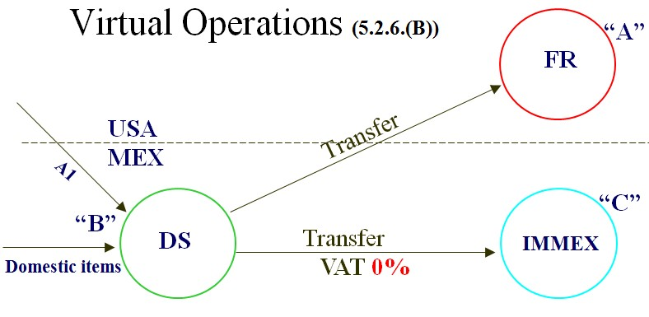

Business Relationship |  | Customs Operations |  | Transfer of Goods
Seller (Supplier) | Buyer(Customer) | Importer | Importation Regimen of Transferred Goods | Virtual Exporter | Virtual Importer
“A” | “B”
Companies with Strategic Fiscal Warehouse | 1.- IMMEX Company 2.- OEM or Fiscal  Warehouse Manufacturer (Deposito Fiscal) |  |  | Companies with Strategic Fiscal Warehouse | 1.- IMMEX Company  2.- OEM or Fiscal Warehouse Manufacturer (Deposito Fiscal)

Rule (5.2.6.(C))

“A" – Strategic Fiscal Warehouse Company which sells and ship to in México to another IMMEX

“B" – IMMEX Buys.

