PURPOSE:
- The purpose of the document is to communicate Johnson Controls Inc. requirements to the suppliers in our Automotive Experience Division and Corporate Worldwide Headquarters. It is the expectation of Johnson Controls Inc. that all suppliers of Tooling comply with all of the requirements and expectations documented below.

• Johnson Controls Inc. expects this document to provide the foundation for our working relationship with our Suppliers. We will strive for excellence through continuous improvement in the products and services we receive through close working relationships with our suppliers.

SCOPE
- This policy applies to the JCI Automotive Experience (AE) manufacturing locations that are involved in the purchase of products and services for use internally or resale. The required invoice information may differ by region. Please contact the invoice approver that is identified on the purchase order or the tooling buyer for further questions.

Table of Contents

1.0 General Expectations

2.0 Required Invoice Information (RII)

3.0 Sending Invoices to Johnson Controls
3.1Supplier Self Service Portal (SSSP) - Taulia
3.2 Email (Non human email account)

1. 0 General Expectations:

• All required documentation must be submitted through the JCI SSSP – Taulia.
• Submitting invoices and the RII outside of the SSSP - Taulia will result in delays in processing the invoice.
• For factored purchase orders, the invoice value must match the JCI purchase order –
Factoring schedule value.
• All of the documents need to be submitted in the required invoice information package in the original/converted PDF format.
• The order of the required documents is critical as shown below in the RII section to ensure prompt invoice processing.
• For additional information or clarification about the RII, please contact the invoice approver as identified on the purchase order.

2.0 Required Invoice Information (RII):

• The Supplier must include all required documentation (if applicable) as stated below when submitting tooling invoices to JCI. Please enter in comments section in Taulia what payment it is if it is a partial payment (Example: Payment 1 of 2).

- 1st and 2nd payments only
- A copy of the invoice itemized per the PO lines. It must have the PO number, tool numbers and factored amount (if applicable). Invoices entered into SSSP - Taulia automatically have all this information on it.
- A copy of the PO
- A copy of the factoring schedule (if applicable)
- Identify in the “Notes” which payment is being invoiced.

- Final payments
- A copy of the invoice itemized per the PO lines. It must have the PO number, tool numbers and factored amount (if applicable). Invoices entered into SSSP - Taulia automatically have all this information on it.
- A copy of the PO
- A copy of the factoring schedule (if applicable)
- A copy of the Tool Data Sheet for Stampings only. This will need to be
Supplied for new tools and any changes that impact the data on the Tool Data Sheet. The Tool Data Sheets are located on the supplier portal in the Supplier Standards Manual in the Tooling Chapter. Tooling Invoice Information (RII).

- Tool Information Sheets (TIS). These only need to be filled out in the
case of NEW TOOLS AND REFURBISHED TOOLS. The Tooling
Information Sheets are located on the supplier portal in the Supplier
Standards Manual in the Tooling Chapter.
Tooling Invoice Information (RII).
- Digital photos clearly showing the required items (Close up picture of the tool tag. Picture of entire tool with the tool tag). The photos are to be in a JPEG format, in COLOR and inserted into the Tooling Information Sheets.
- Tool identification (tagging) as specified in the latest JCI tooling standards. Tool tags must be legible and clear in photos. Contact your program team for specific customer tool tagging requirements as it is different for each OEM.
- When submitting final invoice, Tooling Information Sheets are to be
converted to an original PDF format before attaching in SSSP - Taulia (see appendix A for conversion instructions)
- PSW/PPAP for new tools and changes (must be a level 3 to 5) – Full service suppliers or suppliers who procure their own tooling and provide parts/components from these tools to JCI may also be required to include a JCI approved PSW/PPAP with matching JCI part number (s) and tool ID number(s). The PSW/PPAP approval must be for the parts that correspond to the tooling and equipment per the invoice. Contact the invoice approver as identified on the purchase order if you have any questions regarding PSW / PPAP requirements.

3.0 Sending Invoices to Johnson Controls:
Johnson Controls request that suppliers follow the preferred method of sending
invoices. This will ensure that the supplier’s invoices are processed in a timely
manner.

3.1 Supplier Self Service Portal (SSSP) – Taulia;
The Taulia SSSP launched in September 2012. The Taulia SSSP offers a variety of services to the external supply base – such as invoice and payment verification, e-invoicing, purchase order visibility, and vendor master data management.

• This is the preferred method for suppliers sending tooling invoices to Johnson
Controls.
• If a supplier registration is needed for the Taulia SSSP click the following link and follow the instructions https://johnsoncontrols.inquisiteasp.com/cgi-bin/qwebcorporate.dll?idx=53RNZK. Once you have provided your company contact information you will receive and invitation.

• If you are currently registered in the Taulia SSSP you can access by clicking the following link Click Here to Access SSSP
• If your company is registered and you do not have a user id you can access by clicking the following link Click Here to Access SSSP and selecting first time user
• For general information on the Taulia SSSP and frequently asked questions –
Click here

3.2 Emailing invoices to Johnson Controls is an alternative option. This email address is a non human email account. Please note that sending invoices outside of the Taulia SSSP may result in delays in processing the invoice.

• When submitting an invoice outside of the Taulia SSSP, the Tooling Invoice Approval
Form (TIAF) is required. The TIAF can be located within the Required Invoice
Information document on the supplier portal in the Tooling Invoice Information (RII).
• The possibility of sending invoices by e-mail in PDF is available only if invoicing to a Johnson Controls entity, which is located in:
• USA
• Canada
• European Union (excluded France) E-mail addresses for PDF invoices:
• For USA, Mexico and Canada: AP-AE-NA-BBC-Invoice-Copies@jci.com
• For European Union (excl. France): ap-ae-eu-bbc-einvoice@jci.com

3.3 Invoice Inquiries should be sent directly to CORP-BBC-RTR-AE-Tooling-AP@jci.com

Additional Notes:

• Suppliers may need to have Adobe Pro to submit Required Invoice
Information.
• Create ONE PDF file/package per invoice.
• See Appendix A for instructions to convert documents into PDF format

Appendix A

Create one PDF file/package in Adobe Pro if you have multiple attachments.

Step 1:
Open each attachment in their respective software program.
Step 2:
Select the option to print → adobe printer
→Save the file to a place you will
Remember.

Step 3:
Open Adobe Pro → Open all files you wish to
Combine

Step 5:
A window will pop up select add file → add open files
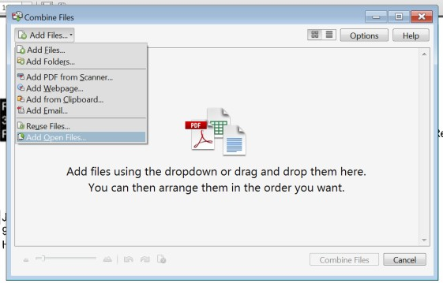

Step 7:
The file will then combine and a new file will pop up
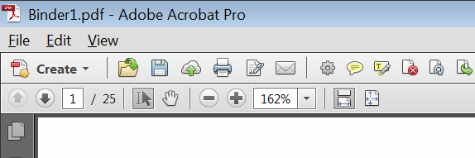
Named Binder “#”
Step 4:
Then select create → Combine files into single
PDF
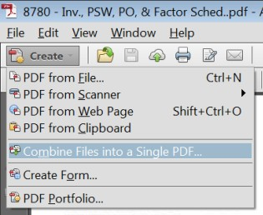

Step 6:
All files will appear in this window → Combine
Files
Please note: if you have selected too many files you may highlight them
Click (Remove Selected Items)
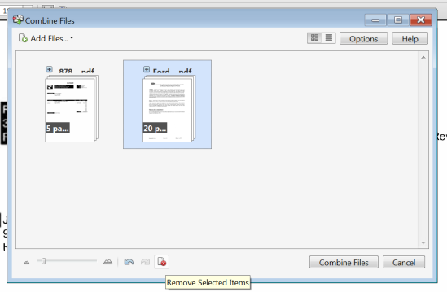

Step 8:
Save the file to a location → Utilize this file to attach to the Taulia record

Please note: The pdf document ORDER w/in the combined pdf files should match the latest Required Invoice Information package instructions.

