PURPOSE
- The purpose of the Global Supplier Standards Manual is to communicate Adient requirements to the suppliers in our Automotive Experience Division that provide prototype parts. It is the expectation of Adient that all suppliers of Direct Materials comply with all of the requirements and expectations documented in this manual.

- Adient expects this manual to provide the foundation for our working relationship with our Suppliers. We will strive for excellence through continuous improvement in the products and services we receive through close working relationships with our suppliers.

- This standard is a supplement to and does not replace or alter other terms and conditions covered by purchase documents, procedures or requirements of engineering drawings or specifications.

SCOPE
Geographic Applicability-
- This policy applies globally to all Adient Automotive Experience (AE) Manufacturing and Parts Distributions locations that are involved in the purchase of products and services for use internally or resale.

- The Prototype manual is divided into 4 main sections

- General Quality Requirements
- Required Quality Documentation
- Quality Documentation – Process, Submission and Naming
- Miscellaneous and Special Requirements

General Quality Requirements
The requirements have to be fulfilled and documentation has to be prepared. Full documentation has to be sent with each delivery with regard to the definition of basic documents.

All documents have to be centralized within the “Central-QRM-Documentation”.

PPSW (Prototype Part Submission Warrant)
The cover sheet is mandatory for every delivery and each ordered part number. It is mandatory to fill out the complete PPSW.

Marked-Up-Drawing
Marked dimensions have to correlate to the items in the measurement report, e.g. position one on the drawing correlates to measurement one on the report. The supplier is responsible to prepare the marked-up drawing.

Inspection Report
The Inspection report is used to document dimensions and features not captured with the CMM report. Material, gage, functional checks, weld seam length, weld seam quantity, hardness, dimensions (fastener), etc. The Inspection report is to be integrated in Central-QRM-Documentation. Each item on the report has to correlate to the marked up drawing, e.g. position one on drawing correlates to position one on measurement report. At a minimum the report has to provide the following information:
    - Nominal value
    - Actual value
    - Tolerance
    - Assessment OK / NOK

CMM Report
A three piece 100% CMM measurement report is mandatory except for fasteners (see 2.5). If a PO is split in different production lots, three parts have to be measured with the first batch. With all following batches, one part has to be measured (see 2.2). At a minimum the report has to provide the following information:
    - Nominal value
    - Actual value
    - Tolerance

    - Assessment OK / NOK
    - Alignment (datum structure, etc.)
    - Road Map (see 2.7)
    - Digital Picture of set up (see 2.6)

CMM reports shall only contain dimensions required on the engineering drawing i.e.; all GD &T feature control frames, hole diameters, etc. No reference dimensions are required and no "T”rim or "S”urface value (Approach Vector detail) will be allowed. All features MUST be checked as called out on the engineering drawing.

Production Pull-Ahead Part Approval
Parts are to be inspected with a third party Adient approved production gage. In case a gage is not available, a CMM report is required unless the GD&T allows a hand layout (1.3). In case material is out of specification, a CMM or Inspection report is mandatory for the DA approval. All other sections of this QRM manual shall apply.

Production Carry Over and Standard Parts
PPAP production and standard parts only require a shipper (see 1.10). No other quality documentation is required.

Box Label and Part Identification
General Note
    - coat resistant labels are the preferred identification method and can be used instead of engraving/etching. Each and every part or assembly has to be individually identified. Parts too small to carry the entire information can be handled by abbreviating the information. Parts too small to carry even the abbreviated information can be handled with a box label. The part, assembly, or box label has to contain the following information:
      - Part Number
      - Revision Level
      - DA number if applicable
      - Batch Number
If not clearly defined on drawing the position and method of identification has to be agreed upon with Adient.

Single Components
Engraved/Etched: If part is not e-coated by the supplier. Labeling: If part has been e-coated by the supplier.

Sub and Final Assembly
Engraved/Etched: If the property is not to be e-coated the supplier. Labeling: If a part has been e-coated by the supplier. All quality information gathered must reference the label number and the associated quality documentation has to match the bar code number.

Bar Code Requirement
The following information is intended to provide the supplier with the bar code information required to ship parts to the Adient prototype shop. All of the following requirements must be met.

Barcode
      - Must be code 39 or code 128 format
      - Data: SvvNNNNN
        - S=Serial Id prefix (Always capital “S”)
        - vv= Vendor code (Assigned by Adient Prototype- never changes for supplier)
        - NNNNN= serial (00001-99999 or 00000-ZZZZZ; must be unique)
The bar code must be readable (scanner test) and no two labels can have the same serial number.
Human readable
      - The serial number SvvNNNNN is required to be in human readable format
      - The item number, revision deviation and batch numbers must uniquely identify an individual part
      - Vendor Name

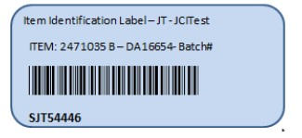

Inspection plan (if requested)
The inspection plan has to be provided by the supplier and has to be created per each part. The supplier’s own format can be used, but has to be approved by Adient before first delivery. This requirement, if requested, will be listed on the Adient Purchase Order.
Even if not requested the absence of an inspection plan does not relieve the supplier from adhering to the specification on the drawing. The same is true even if an inspection plan has been approved by Adient (see 4.)

The minimum information captured in the inspection plan shall contain:
    - Item of Inspection
    - Type of Inspection
    - Inspection Sequence
    - Type of Documentation

Material Verification page 13
3rd party material verification is mandatory (mechanical, chemical, and statement of conformance). All sheet metal, tube, and wire material requires a 3rd party inspection. Do not start your manufacturing process without having the statement of conformance from your A2LA or 17025 certified laboratories.

All materials require a 3rd party certificate in addition to the mill certificate. The 3rd party certificate must reference the heat batch number of the mill certificate.

    - Tube material shall be tested 180° opposite from weld seam (according to specification). A sub-size specimen is recommended. If available submit the sheet metal certificate of the sheet metal used to manufacture the tubing material.
    - Wire (according to specification).

Fasteners shall be tested in accordance with the standard on the engineered drawing. This test does not require a 3rd party certificate, but must be provided in a report form by the supplier (see 2.3).

Weld Inspection / Macro Analysis (MIG/ MAG/Laser)
General Note
The cut and etch requirements need to be discussed on an individual basis; however, all safety critical welds require a full cut and etch report at all times. None critical welds need to show evidence of fusion (picture and minimum measurements). Any measurements need to be attached in the designated work book of the Central-QRM-Documentation. The report and pictures must be clearly identified and correlate back to the weld seam call out of the print. The measurements must be taken in accordance to the individual OEM specification. If not otherwise specified the supplier has to adhere to the Adient weld requirements as descripted in the specification

    - GMAW Quality/AE-MOS-SP-XX-XX-E
    - Laser Welding Quality/AE-MOS-SP-XX-XX-E;

For Adient Prototype manual welding requirements, see document: Manual Prototype Welding Operator Qualification and Procedures – Vendors to Adient (available upon request).
Robotic
All robotic welded assemblies require weld length, position, visual integrity and presence check/measured of all welds on the first two parts and the last part of the batch. All other parts need to be visually inspected for weld presence and weld integrity and must be individually marked (color dot). All assemblies need to be serialized and all physical and/or visual measurements must be documented (see 1.3 and 1.5).
Manual
All manual welded assemblies require 100% weld length, position, visual integrity and presence check/measured and must be individually marked (color dot). All assemblies need to be serialized and all physical and/or visual measurements must be documented (see 1.3 and 1.5).

1.8.1 Spot Weld/ Resistance Welding
At a minimum the supplier has to adhere to the ISO 10447 standard. The result of the nugget dimension has to be measured and recorded accordingly. If provided with OEM specifications the OEM spec supersedes the ISO standard.

Deviation Authorization Form
With any NOK results or other deviations a DA number has to be requested by supplier to get a decision of further handling (release, rework, new parts, etc.) before sending the parts to Adient.

The supplier will get a feedback on this as follows:

    - Approved DA >>>Parts released with NOK results>>>Parts can be shipped to Adient.
    - Rejected DA>>>Parts not released with NOK results>>>Parts are not allowed to ship to Adient.

With a not released DA the parts have to be reworked or new parts have to be delivered including complete documentation.

With released parts the DA-number or DA form (ideally) has to be documented within the “Central-PPSWDocumentation”.

The DA number shall be listed on the part label (see 1.5).

In advance of any part delivery the DA-request has to be sent to the coordinator in charge or the AQE (Quality Engineer) in order to achieve prompt release by Adient- Engineering. Any report with dimensions out of specification will be used as quality rejection criteria unless the paperwork is submitted with the DA-number.

Shipping Documentation
Any delivery requires a deliver note (shipper). International shipments must comply with the applicable customs regulations and documentation. The following content is required with the delivery note (shipper).
- Shipper
- PO-Number
- Part-Number / Rev.Level
- Batch #
- Counts of parts per each position

Packaging & Delivery of Measured Parts
All measured parts have to be physically separated from the rest of the lot. The samples used for measurement shall be numbered and correspond to the test report.

These measurement parts will be held back for later build trials making this separation is absolutely vital.

Required Quality Documentation

  - Prototype Part Submission Report / Warrant (PPSR)

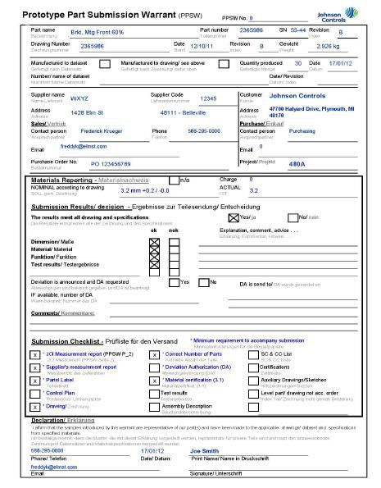

  - Measurement Report Frequency
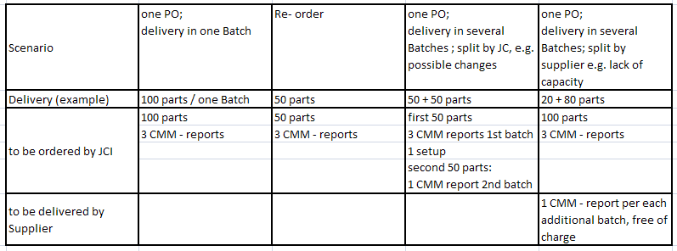

  - Marked-Up Drawing
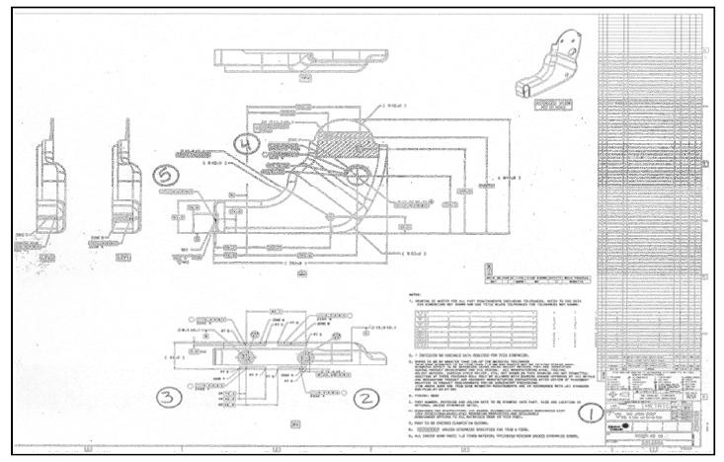

  - Inspection Report
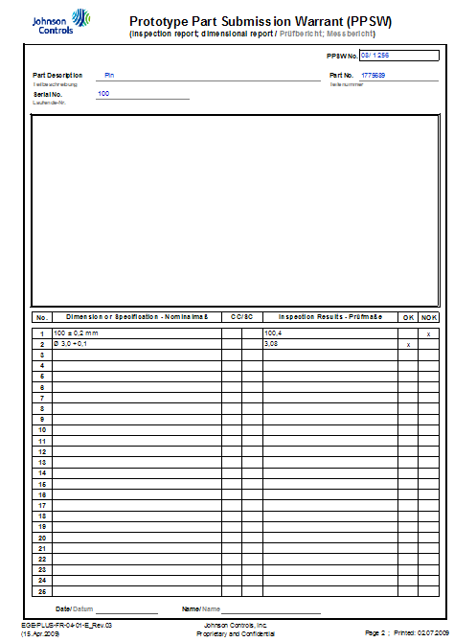

  - CMM Report
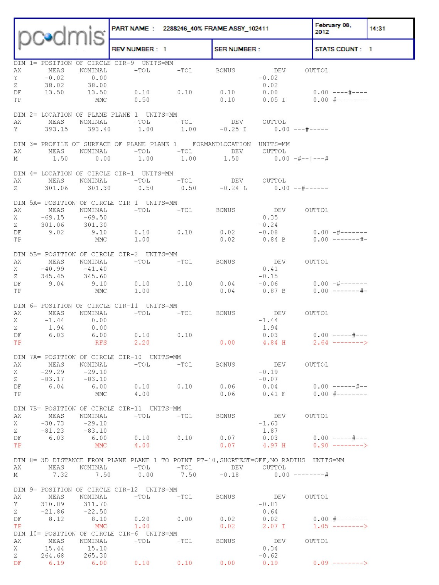

  - Measurement Setup
To make measurements reproducible and to allow counter measuring at least one
    - photo of the measurement setup is required.
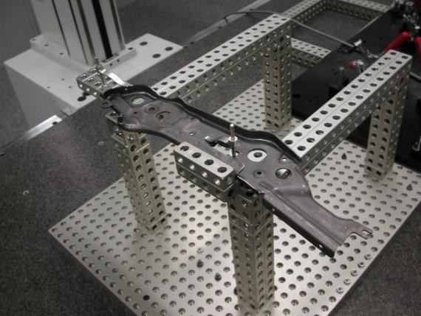

Road Map
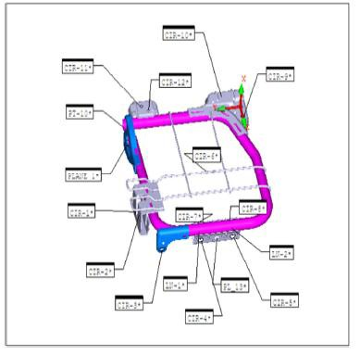

2.7.1 Box Label
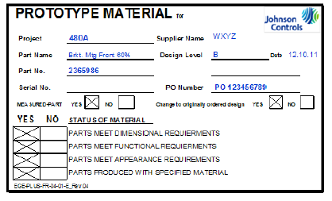

Material Certificate
Mechanical Report Chemical Report Statement of Conformance
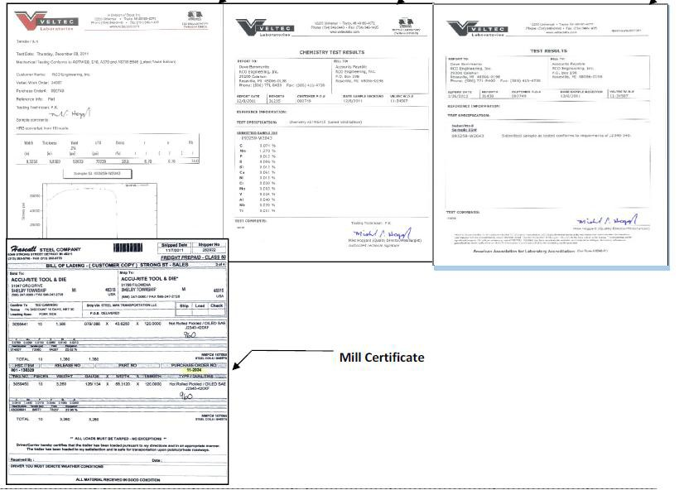

Robotic Weld Inspection / Macro Analysis

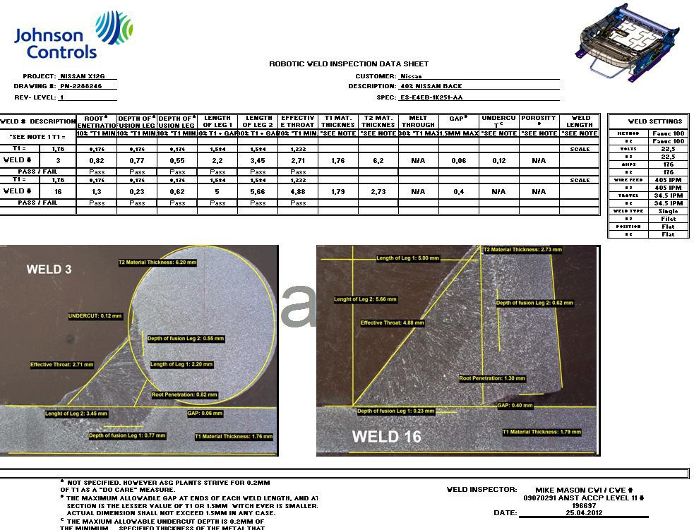

  - Deviation Authorization Request
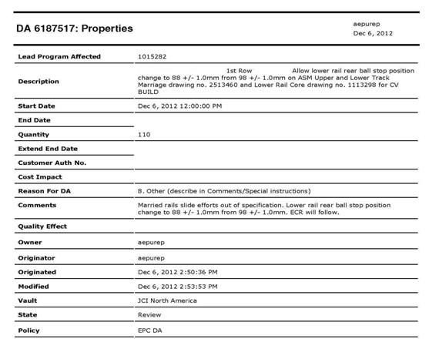

  - Quality Documentation – Process, Submission and Naming

To avoid excessive paperwork, waste of paper and unnecessary queries the Central-QRM-Documentation shall be submitted digitally only.

Naming convention:

Follow the naming convention for the file name: Part number_Supplier manufacturing lot number (alpha numerical)_revision level_project name

Example: 2395855_AZ12_B_X12G

Submission Process
True Prototype Parts
Please send the digital copy of the quality documentation (excel file format) to the following e-mail address aeplymouth-prototype@jci.com and/or the Adient Prototype SAQE unless otherwise requested. If a file is larger than 8Mb please submit via JCDX to the SAQE. The subject must entail the following content:

Part Number + Project Name+ Supplier Name

Production Pull-Ahead Parts
Please send the digital copy of the quality documentation (excel file format) to your Adient Quality Engineer. After review of the quality documentation the Quality Engineer will forward the information to the Adient Prototype SAQE. If a file is larger than 8Mb please submit via JCDX. The subject must entail the following content:

Part Number + Project Name+ Supplier Name

Parts will be placed “on hold” until the quality documentation has been submitted.

4.0 Miscellaneous & Special Agreements
  - The supplier guarantees to adhere to the requirements on the drawing. Surface and material requirements, i.e.; no burrs or corrosion, no scratches, damage, varnish/paint runs and appropriate packaging, are basic requirements and even if not reflected on drawings must be inspected by the supplier.

  - If "not OK"-parts (= quality report stating the parts are not OK) are delivered without an approved DA (Deviation authorization) the quality reports may not be

paid by Adient. The costs for Adient internal re-work and (if applicable) transport costs (back to the supplier) may be charged to the supplier.

